Short term plan: term 3

Unit: The theme of the lesson |  | Lesson 49
Teacher name:

Date:
Grade: 9 |  | Number present: | absent:
Lesson title | Types of fiction
Learning objectives | 9.3.1.1 use formal and informal language registers in their talk on a range of general and curricular topics  9.4.4.1 read a wide range of extended fiction and non-fiction texts on familiar and unfamiliar general and curricular topics
Lesson objectives | Learners will be able to:  - introduce the topic; to read for gist  - listen and read for specific information  - understand a character's feelings
Value links | "Law and Order"  Know the basics of the legal system and human rights
Plan

Stages / Time | Teachers actions | Students actions | Assessment criteria | Resources
Beginning of the lesson  5 min.  Middle of the lesson  Presentation part.  35 min | Organization moment :  1.Greeting.  Ask about the weather.  Warming up  The teacher sets the lesson objectives, letting students know what to anticipate from the lesson.  Lead – In  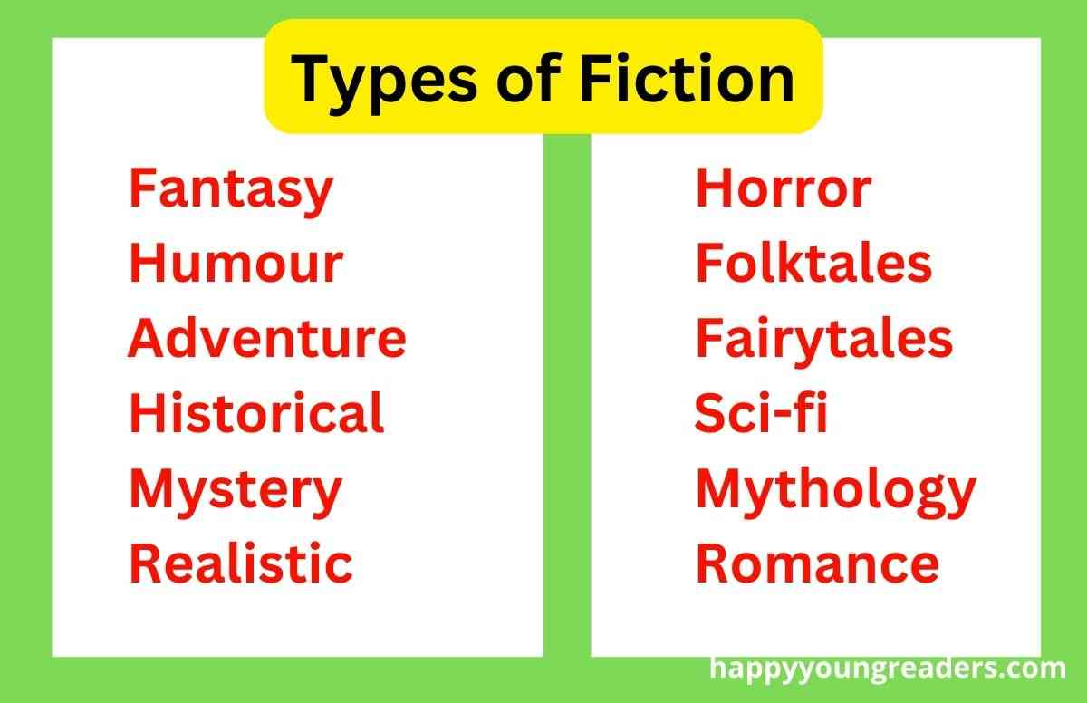  Ex:1 P:53  Read out the genres in the list and elicit a brief description of each one from Ss around the class (fantasy-stories about things that don't exist such as fairies; romance stories about love; comedy - amusing stories; horror scary stories; crime - stories involving a detective; science fiction - stories set in outer space or in the future)  Then give Ss' time to read the extracts and match them to the genres.  Check Ss' answers. | Students of the class are listed.  Students' attention is drawn to the lesson.  Students say different words from the picture  Learners answer the questions  Learners read the extracts. What kind of books do you think they come from? Discuss with your partner.  ANSWERS  1 science fiction  2 horror  3 fantasy | The teacher to assess learners for their ability.  “Good job!  Well done!”  Formative Assessment  Good job!    Descriptor:  - read the biography.  - answer the question  Total: 2 point | Pictures
 | Ex: 2 P: 53  Ask Ss to read the extracts again if necessary and elicit which places inspired the authors to write their novels.  Elicit answers from Ss around the class. | Learners answer the question. Which places inspired each author in Ex. 1 to write their novels?  ANSWERS  1 the steppe of Kazakhstan  2 the town of Whitby, North Yorkshire, UK | Descriptor:  - read the extracts again  - write their novels  Total: 2 point |   Card  Worksheet  Students book
End of the lesson  5 min | FEEDBACK  Learners provide feedback on what they have learned at the lesson.  Ex: P:  Home task: | Ss evaluate each other and encourage classmate with phrases like:  Well done! Brilliant! Good job! I like it! |  | Poster Success  

Short term plan: term 3

Unit: 5 Reading for pleasure |  | Lesson 50
Teacher name:

Date:
Grade: 9 |  | Number present: | absent:
Lesson title | The Canterville Ghost
Learning objectives | 9.3.1.1 use formal and informal language registers in their talk on a range of general and curricular topics  9.4.4.1 read a wide range of extended fiction and non-fiction texts on familiar and unfamiliar general and curricular topics
Lesson objectives | Learners will be able to:  - introduce the topic; to read for gist  - listen and read for specific information  - understand a character's feelings
Value links | "Law and Order"  Observance of norms and rules of order and justice understand the need
Plan

Stages / Time | Teachers actions | Students actions | Assessment criteria | Resources
Beginning of the lesson  5 min.  Middle of the lesson  Presentation part.  35 min | Organization moment :  1.Greeting.  Ask about the weather.  Warming up  The teacher sets the lesson objectives, letting students know what to anticipate from the lesson.  Lead – In    Ex:1 P:54  Elicit what, if anything, Ss know about Oscar Wilde and the stories he wrote.  Direct Ss to the picture and the biography of Oscar Wilde and ask them to read the biography and answer the questions.  Elicit answers from Ss around the class | Students of the class are listed.  Students' attention is drawn to the lesson.  Students say different words from the picture  Learners answer the questions  Learners read the biography. Answer the question.  ANSWERS  Oscar Wilde wrote a lot of literature: poems, articles for magazines and newspapers, collections of fairy tales, several funny plays and a novel. The Canterville Ghost is a novella with elements of both comedy and horror | The teacher to assess learners for their ability.  “Good job!  Well done!”  Formative Assessment    Good job!  Descriptor:  - read the biography.  - answer the question  Total: 2 point | Pictures
 | Ex: 2 P: 54  Ask Ss to look at the pictures and elicit their guesses as to whether the people in the pictures are afraid of the ghost or not.  Play the recording.  Ss listen and read the text to find out.  Check Ss' answers.  Ex: 3 P: 54  Give Ss time to read the text again and the sentences. Then, Ss mark them as true, false or doesn't say.  Check Ss' answers.  Ex: 5 P: 55  Give Ss time to match the words in the column to form phrases from the text.  Check Ss' answers.  Ex: 6 P: 55  Explain the task. Ss complete the task and check their answers in the text  Ex: 7 P: 55  Allow Ss time to look up the meanings of the words in the list in their dictionaries if necessary.  Elicit definitions from Ss around the class.  Then give Ss time to use them to complete the sentences.  Check Ss answers. | Learners look at the pictures. Answer the question.  ANSWERS  The people in the pictures are not afraid of the Canterville Ghost.  Learners read the extract and mark the statements.  ANSWERS  1F  2 F  3 F  4 DS  5 T  Learners match the columns  ANSWERS  1 b  2 d  3 e  4 a  5 c  Learners choose the correct item  ANSWERS  1 in  2 to  3 at  4 down  5 onto  Learners complete the sentences. Use the words in the box  ANSWERS  1 rude 2 afraid  3 clank 4 insulted  5 sight | Descriptor:  - look at the pictures.  - answer the question.  Total: 2 point  Descriptor:  - read the extract  - mark the statements.  Total: 2 point  Descriptor:  - match the columns  Total: 1 point  Descriptor:  - choose the correct item  Total: 1 point  Descriptor:  - complete the sentences.  - Use the words in the box  Total: 1 point  -Make CCQ questions Yes / No | Students book
End of the lesson  5 min | FEEDBACK  Learners provide feedback on what they have learned at the lesson.  Ex: P:  Home task: | Ss evaluate each other and encourage classmate with phrases like:  Well done! Brilliant! Good job! I like it! |  | Poster Success

Short term plan: term 3

Unit 5 Reading for pleasure |  | Lesson 51
School
Teacher name:

Date:
Grade: 9 |  | Number present: | absent:
Lesson title | Journey to the Centre of the Earth
Learning objectives | 9.2.4.1 understand the main points of supported extended talk on a range of general and curricular topics  9.4.4.1 read a wide range of extended fiction and non-fiction texts on familiar and unfamiliar general and curricular topics
Lesson objectives | Learners will be able to:  - introduce the topic, to read for specific information  - listen and read for specific information  -consolidate new vocabulary
Value links | "Law and Order"  Ensuring the protection and safety of society understand the importance of law and order as
Plan

Stages / Time | Teachers actions | Students actions | Assessment criteria | Resources
Beginning of the lesson  5 min  Middle of the lesson  Presentation part.  35 min | Organization moment :  1.Greeting.  Ask about the weather.  Warming up  The teacher sets the lesson objectives, letting students know what to anticipate from the lesson.  Lead – In    Ex:1 P:56  Elicit what, if anything, Ss know about Jules Verne and the stories he wrote.  Direct Ss to the picture and the biography of Jules Verne and ask them to read the biography and answer the questions.  Elicit answers from Ss around the class. | Students of the class are listed.  Students' attention is drawn to the lesson.  Determines the topic and purpose of the lesson  Learners remember previous lesson vocabulary  Students say different words from the picture  Answer the question.  Pupils read the biography. Answer the question.  ANSWERS  Jules Verne wrote adventure stories. The main characters in Journey to the Centre of the Earth are a scientist, the Professor, his nephew, Axel, and their guide, Hans. | The teacher to assess learners for their ability.  “Good job!  Well done!”  Formative Assessment    Good job!  Descriptor:  - read the biography  - answer the question.  Total: 2 point | Pictures
 | Ex: 2 P: 56  Read out the questions.  Play the recording. Ss listen and read the text to find out the answers  Differentiation: «Verbal support» method is used to help Ss use new words in the sentences.  Differentiation: «Verbal support» method is used to help Ss use new words in the sentences.  Ex: 3 P: 57  Ask Ss to read the sentence stems.  Give Ss time to read the extract and complete the task.  Check Ss' answers.  Ex: 4 P: 57  Direct Ss to the words in the list and then give the time to find the adjectives the writer uses describe them.  Check Ss' answers. | Pupils look at the picture. Answer the question.  ANSWERS  The people in the picture are the Professor, Axel and Hans. They are under the Earth, inside something like a giant cave and the top of it is a few miles high. Axel is the one who narrates the story.  Pupils read the extract and complete the sentences.  ANSWERS  1 the heat of the rocks  2 bones (of sth which looked like a huge elephant)  3 how deep the sea was  4 teeth  Pupils find the adjectives the writer uses in the story.  ANSWERS  the cave = giant  the sea underground, strange  the marks on the pickaxe = large  the wind = strong  the waves = huge  the head of the pickaxe = meta | Descriptor:  - look at the picture  - answer the question  Total: 2 point  Descriptor:  - read the extract  - complete the sentences.  Total: 2 point  Descriptor:  - find the adjectives  Total: 1point  -Make CCQ questions Yes / No  Total: 1 point  Total: 10 point | Card  Worksheet  Students book
End of the lesson  5 min | FEEDBACK  Learners provide feedback on what they have learned at the lesson.  Ex: P:  Home task:  Write the days | Ss evaluate each other and encourage classmate with phrases like:  Well done! Brilliant! Good job! I like it! |  | Poster Success

Short term plan: term 3

Unit 5 Reading for pleasure |  | Lesson 52
Teacher name:

Date:
Grade: 9 |  | Number present: | absent:
Lesson title | Clauses of concession
Learning objectives | 9.3.7.1 use appropriate subject-specific vocabulary and syntax to talk about an increased range of general and curricular topics  9.6.5.1 use a wide variety of question types on a wide range of familiar general and curricular topics  9.5.8.1 spell most high-frequency vocabulary accurately for a wide range of familiar general and curricular topics
Lesson objectives | Learners will be able to:  - to clauses of concession  - to develop character empathy skills
Value links | "Law and Order"  Know the basics of the legal system and human rights
Plan

Stages / Time | Teachers actions | Students actions | Assessment criteria | Resources
Beginning of the lesson  5 min  Middle of the lesson  Presentation part.  35 min | Organization moment :  1.Greeting.  Ask about the weather.  Warming up  The teacher sets the lesson objectives, letting students know what to anticipate from the lesson.  Lead – In  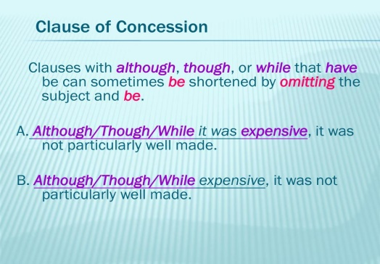  Ex: 5 P: 57  Read out the box and explain the task.  Give Ss time to use them to complete the sentences.  Check Ss' answers. | Students' attention is drawn to the lesson.  Learners remember previous lesson vocabulary  Determines the topic and purpose of the lesson  Students say different words from the picture  Pupils read the box, then complete the sentences.  ANSWERS  1 off  2 up  3 back  4 aside | The teacher to assess learners for their ability.  “Good job!  Well done!”  Formative Assessment  Good job!  Descriptor:  - read the box  - complete the sentences.  Total: 2point | Pictures
 | Ex: 6 P: 57  Go through the theory table and read the examples aloud.  Elicit the L1 equivalents for the examples.  Then, explain the task and give Ss time to complete it.  Check Ss' answers around the class.  Differentiation: «Verbal support» method is used to help Ss use new words in the sentences  Ex:7a P: 57  Explain the task and give Ss time to complete it.  Display the pictures on the classroom walls.  Ex: 7b P: 57  Ask Ss to imagine they are a character in the story and have them consider the questions and then tell their partner.  Then ask various Ss around the class to share their answers with the rest of the class.  Conclusion during the lesson some tasks differentiated by outcomes of the students and by their abilities. | Pupils read the theory. Complete the sentences.  ANSWERS  1 though  2 but  3 Even though/Although/Though  4 while/whereas  5 though  Pupils read the Iast part of the extract. Use the descriptions to draw the monsters.  ANSWERS  Students own answer  Pupils look at the picture. Answer the question.  ANSWERS  I feel very excited. I have never seen any creatures like those before. I don't know what to expect and I am a little scared in case something terrible happens to me. | Descriptor:  - read the theory  - Complete the sentences.  Total: 2 point  Descriptor:  - read the Iast part of the extract  - use the descriptions  Total: 1 point  Descriptor:  - look at the picture.  - answer the question.  Total: 1 point  -Make CCQ questions Yes / No | Card  Worksheet
End of the lesson  5 min | FEEDBACK  Learners provide feedback on what they have learned at the lesson.  Ex:  Home task: |  |  | Poster Success

Short term plan: term 3

Unit 5: Reading for pleasure |  | Lesson 52
Teacher name:

Date:
Grade: 9 |  | Number present: | absent:
Lesson title | The Worth of Wealth
Learning objectives | 9.2.6.1 deduce meaning from context in unsupported extended talk on a wide range of general and curricular topics, including talk on a limited range of unfamiliar topics  9.4.5.1 deduce meaning from context in short texts on a limited range of familiar general and curricular topics
Lesson objectives | Learners will be able to:  - introduce the topic and key vocabulary  - listen and read for gist  - read for specific information (multiple choice)
Value links | "Law and Order"  Observance of norms and rules of order and justice understand the need
Plan

Stages / Time | Teachers actions | Students actions | Assessment criteria | Resources
Beginning of the lesson  5 min  Middle of the lesson  Presentation part.  35 min | Organization moment :  1.Greeting.  Ask about the weather.  Warming up  The teacher sets the lesson objectives, letting students know what to anticipate from the lesson.  Lead – In    Ex:1 P:58  Ask Ss to look at the list of the Seven Deadly Sins.  Elicit what, if anything, Ss know about them.  Allow Ss time to check the words in their dictionaries.  Elicit answers from Ss around the class | Students of the class are listed.  Students' attention is drawn to the lesson.  Determines the topic and purpose of the lesson  Students say different words from the picture  Pupils look at the list of the Seven Deadly Sins. Use your dictionary to explain their meaning.  ANSWERS  Pride = a very high opinion of yourself  Envy = jealousy of others  Gluttony = being greedy with food  Lust a strong desire to have sth  Anger = strong negative feelings against sb  Greed = having a selfish desire for wealth or power  Sloth = being very lazy | The teacher to assess learners for their ability.  “Good job!  Well done!”  Formative Assessment  Good job!  Descriptor:  - look at the list  - use your dictionary to explain their meaning.  Total: 2 point | Pictures
 | Ex: 2 P: 58  Ask Ss to read the title and the first sentence in each paragraph.  Elicit Ss' guesses as to what the folk tale is about and which of the Seven Deadly Sins it refers to.  Play the recording. Ss listen and read the text to find out the answers  Ex: 3 P: 59  Ask Ss to read the questions (1-4) and answer choices A-C.  Give Ss time to read the text and complete the task.  Check Ss' answers around the class.  Ex: 4 P: 59  •Direct Ss to the words in bold in the text and then give them time to match them to the definitions in the list.  Check Ss' answers.  Ex: 5 P: 59  Give Ss time to consider the question.  Then ask various Ss around the class to share their answers with the class.  Ex: 7 P: 59  Ask Ss to read the events and put them in the correct order referring back to the text as necessary.  Check Ss' answers. | Pupils read the title and the first sentence in each paragraph. Answer the question.  ANSWERS  I think the folk tale is about greed.  Pupils read the folk tale and for question choose the correct answer.  ANSWERS  1 C  2 A  3 B  4 A  Pupils match the words in bold to their meaning. Use your dictionary.  ANSWERS  poverty = the state of not having enough  exhausted = very tired  starving = extremely hungry  abandoned = with no one living there  contented = the state of being happy with what you have eternal = lasting forever.  Pupils find the moral in the folk tale.  ANSWERS  I think the moral of the story is that if you are greedy nothing will ever be enough and you will never be happy  Pupils put the events in the order they happened.  ANSWERS  a 3 b 6 c 2 d 7 e 5  f 1 g 9 h 8 I 4 | Descriptor:  - read the title  - answer the question.  Total: 2 point  Descriptor:  - read the folk tale  -. choose the correct answer  Total: 1 point  Descriptor:  - match the words  - use your dictionary.  Total: 2 point  Descriptor:  - find the moral in the folk tale.  Total: 1 point  Descriptor:  - put the events in the order  Total: 1 point  -Make CCQ questions Yes / No  Total: 1 point  Total: 10 point | Card  Worksheet  Students book
End of the lesson  5 min | FEEDBACK  Learners provide feedback on what they have learned at the lesson.  Ex:  Home task: | Ss evaluate each other and encourage classmate with phrases like:  Well done! Brilliant! Good job! I like it! |  | Poster Success
Short term plan: term 3

Unit: 5 Reading for pleasure |  | Lesson 53
Teacher name:

Date:
Grade:9 |  | Number present: | absent:
Lesson title | Speaking and writing
Learning objectives | 9.4.5.1 deduce meaning from context in extended texts on a wide range of familiar general and curricular topics, and some unfamiliar topics  9.5.1.1 plan, write, edit and proofread work at text level with support on a limited range of general and curricular topics
Lesson objectives | Learners will be able to:  -participate in grade appropriate oral and written exchanges of information, ideas, and analyses, responding to peer comments and questions  -employ subject specific vocabulary and grammar in oral discourse
Value links | "Law and Order"  Ensuring the protection and safety of society understand the importance of law and order as
Plan

Stages / Time | Teachers actions | Students actions | Assessment criteria | Resources
Beginning of the lesson  3 min  Middle of the lesson  Presentation part.  35 min | Organization moment :  1.Greeting.  Ask about the weather.  Warming up  The teacher sets the lesson objectives, letting students know what to anticipate from the lesson.  Ex: 7b P: 59  Explain the task. Tell Ss to use their answers in Ex. 7a to say or write a summary of the story.  Ask various Ss around the class to say or read their summaries aloud to the class. | Students' attention is drawn to the lesson.  Learners talk about days of the week previous lesson vocabulary  Determines the topic and purpose of the lesson  Students say different words from the picture  Pupils use your answers in ex 7a to give or write a summary of the folk tale.  ANSWERS  Sağat is exhausted and starving. He sits down at the side of the road. He fell asleep and dreamed of an old man. The old man told Sağat about a magic purse. Sağat woke up and went to find the purse. He thought about what he would buy for his family if he found the purse. Sağat found the purse. Sağat imagined being a very rich man. He opened and closed the purse many, many times. Sağat forgot about his family and he eventually starved to death. | The teacher to assess learners for their ability.  “Good job!  Well done!”  Formative Assessment  Good job!  Descriptor:  - use your answers  - write a summary of the folk tale  Total: 2 point | Pictures
 | Ex: 8 P: 59  Explain the task and ask Ss to work in small groups. Tell them to divide the story into six parts and then draw a picture for each part to make a frame of a comic strip.  Give Ss time to complete the task in class or assign the task as HW.  Display the comic strips around the classroom  Differentiation: «Verbal support» method is used to help Ss use new words in the sentences.  Ex: 9 P: 59  Explain the task. Divide the class into small groups and give them time to research online and find a folk tale, and list the events in order they happened.  Ask groups to present the folk tale to the class.  Alternatively, assign the task as HW and have Ss present their folk tale in the next lesson.  . | Pupils draw the story of “Worth of Wealth” as a comic.  ANSWERS  Students own answer.  Pupils group work. research online and find a folk tale, and list the events in order they happened  ANSWERS  1 A wise man visits the capital city of a famous king.  2 He finds a coin on the street.  3 He decides to give it to a needy person  4 He doesn't find anyone who needs it.  5 The next day he sees the king going to war.  6. The king asks the wise man for his blessing.  7 The wise man gives him the coin.  8 The king is angry.  9 The wise man tells the king that everyone in the city is satisfied except him.  10 The king decides not to go to war | Descriptor:  - draw the story  - complete the task  Total: 2 point  Descriptor:  - group work  - research online and find a folk tale  - list the events in order  Total: 3 point  -Make CCQ questions Yes / No  Total: 1 point  Total: 10 point
End of the lesson  5 min | FEEDBACK  Learners provide feedback on what they have learned at the lesson.  Ex:  Home task: | Ss evaluate each other and encourage classmate with phrases like:  Well done! Brilliant! Good job! I like it! |  | Poster Success
Short term plan: term 3

Unit 5 Reading for pleasure |  | Lesson 54
Teacher name:

Date:
Grade: 9 |  | Number present: | absent:
Lesson title | The promised land
Learning objectives | 9.2.7.1 recognize typical features at word, sentence and text level of a range of spoken genres  9.4.5.1 deduce meaning from context in extended texts on a wide range of familiar general and curricular topics, and some unfamiliar topics
Lesson objectives | Learners will be able to:  -develop and present ideas according to a given role and suggested situation;  - identify the meaning of words using contextual clues
Value links | "Law and Order"  Know the basics of the legal system and human rights
Plan

Stages / Time | Teachers actions | Students actions | Assessment criteria | Resources
Beginning of the lesson  5 min  Middle of the lesson  Presentation part.  35 min | Organization moment :  1.Greeting.  Ask about the weather.  Warming up  The teacher sets the lesson objectives, letting students know what to anticipate from the lesson.  Lead – In  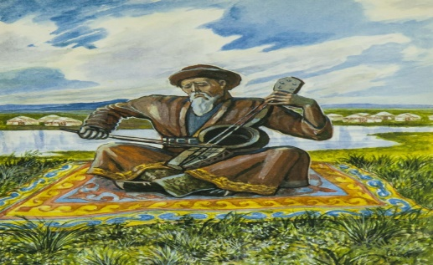  Ex:1 P:60  To introduce the topic; to listen and read for gist  Ask Ss to read the definition and elicit Ss' guesses as to how it relates to the text.  Play the recording. Ss listen and read the text to find out.  Elicit answers from Ss around the class. | Students' attention is drawn to the lesson.  Determines the topic and purpose of the lesson  Learners talk about favourite dayprevious lesson vocabulary  Students say different words from the picture and count one to hundred  Pupils read the definition. Answer the question.  ANSWERS  Utopia relates to the text because it is about Asan Kaigy who was looking for 'Zheruyik' which was utopia to him. | The teacher to assess learners for their ability.  “Good job!  Well done!”  Formative Assessment  Good job!  Descriptor:  - read the definition  - answer the question.  Total: 2 point | Pictures
 | Ex: 2 P: 61  To read for specific information (comprehension questions)  Explain the task.  Allow Ss time to read the questions and then read the text again and complete the task.  Check Ss' answers.  Ex: 4 P: 61  To consolidate new vocabulary  Give Ss time to find the words in the text that match the definitions in the list.  Check Ss' answers around the class.  Ex: 5 P: 61  To consolidate new vocabulary  Give Ss time to look up the meanings of the words in the list in their dictionaries.  Elicit definitions from Ss around the class.  Then give Ss time to use them to complete the sentences.  Check Ss' answers.  Ex: 6 P: 61  Give Ss time to read the summary and complete the gaps with the correct preposition or particle  Check Ss' answers.  . | Pupils read the text. Answer the question.  ANSWERS  1 Asan Kaigy leamed to respect nature from his father's work.  2 Asan knew how to hunt, he was well-educated and trained in military theory.  3 Asan cared about the Kazakh people and worried about their future.  4 Asan travelled around Kazakhstan (on his camel) searching for 'Zheruyik', the promised land.  5 The legend says that he could only die when he had finished the work he was supposed to do on Earth and that in difficult times when people might be in danger he will come back.  Pupils find the words in the text.  ANSWERS  someone that hunts= hunter  someone that gives advice advisor  someone that thinks a lot about important issues= philosopher  Pupils complete the sentences.  ANSWERS  1 troubled  2 goal  3 quest  4 living  5 fertile  6 mystery  Pupils complete the summary with the correct prepositions  ANSWERS  1 in  2 for  3 to  4 in  5 on  6 for  7 in  6 for | Descriptor:  - read the text  - answer the question.  Total: 2 point  Descriptor:  - find the words in the text.  Total: 1 point  Descriptor:  - complete the sentences.  Total: 1 point  Descriptor:  - complete the summary  - complete the gaps with the correct preposition  Total: 1 point  -Make CCQ questions Yes / No  Total: 10 point | Card  Worksheet  Students book
End of the lesson  5 min | FEEDBACK  Learners provide feedback on what they have learned at the lesson.  Ex: Home task: | Ss evaluate each other and encourage classmate with phrases like:  Well done! Brilliant! Good job! I like it! |  | Poster Success

Short term plan Term 3

Unit 5 Reading for pleasure |  | Lesson55

Teacher name:

Date:
Grade: 9 |  | Number present: | absent:
Lesson title | Edutainment: the values of storytelling
Learning objectives | 9.3.4.1 respond with growing flexibility at both sentence and discourse level to unexpected comments on a range of general and curricular topics;  9.4.5.1 deduce meaning from context in extended texts on a wide range of familiar general and curricular topics, and some unfamiliar topics
Lesson objectives | Learners will be able to:  - identify the meaning of words using contextual clues  - check their own and others’ writing to ensure that it communicates what they intended and improve the writing if needed
Value links | "Law and Order"  Observance of norms and rules of order and justice understand the need
Plan

Stages / Time | Teachers’ actions | Students’ actions | Assessment criteria | Resources
Beginning of the lesson  5 min | 1.Greeting.  Ask about the weather.  Warming-up  The teacher sets the lesson objectives, letting students know what to anticipate from the lesson.    Lead – In | Students' attention is drawn to the lesson.  Determines the topic and purpose of the lesson  Learners talk about favourite dayprevious lesson vocabulary  Students say different words from the picture and count one to hundred | At the organization moment T tries to award active Ss.  “Good job!  Well done!”   | Pictures  PPT
Middle of the lesson  Presentation part.  35 min | Ex:1 P:62  Ask Ss to read the quotation and then discuss in pairs what they think it means from both points of view stated.  Elicit answers from Ss around the class.  Ex: 2 P:62  Ask Ss to read the list of statements and tick the ones they consider as values of storytelling.  Then, ask Ss to compare with their partner. Elicit answers from various Ss around the class.  Differentiation:  «Verbal support» method is used to help Students ue new words in the text.  Ex: 4 P:62  Explain the task. Allow Ss some time to read the questions and mark them as T (true) or F (false).  Tell Ss they can review the module and find the relevant information to help them if necessary.  Check Ss' answers.  Ex: 5 P:62  Explain the task and allow Ss time to work in pairs and look through the module and think of quiz questions.  Tell Ss they can use the quiz in the previous task as a model. Offer an example (e.g. Asan's father was a hunter. [T]) | Students discuss the following quotation. Answer the question  ANSWERS:  I think the quotation means that the storyteller and the story reader should both feel like they are living the story and experiencing the events with the characters in the story  Students mark the sentences.  ANSWERS:  Students own answer  Students do the quiz. Mark the statements.  ANSWERS:  1 T  2 F (J.R.R. Tolkien created Middle-earth.)  3 F (Wilde wrote plays and poems, articles, fairy tales, and a novel.  4 T  5T  6 F (Asan Kaigy was born in the 1360s  Students look at the module 5 and write a quiz of your own.  ANSWERS:  1 J.R.R. Tolkien wrote The Lord of the Rings. (T)  2 Dracula is about a group of characters who go on a quest to destroy the forces of evil and save their world. (F Dracula is about a group of friends who are haunted and hunted by an evil vampire.)  3 The Canterville Ghost is Sir Simon de Canterville. (T)  4 Jules Verne dies in 1828. (F-1905)  5 Sağat was an old man. (F. He was a poor man.)  6 Asan Kaigy's father captured eagles. (T) | Descriptor:  - discuss the following quotation  - answer the question  Total: 2 point  Descriptor:  - mark the sentences.  Total: 1 point  Descriptor:  - do the quiz  - Mark the statements  Total: 2 point  Descriptor:  - look at the module 5  - write a quiz of your own.  Total: 3 point  -Make CCQ questions  Yes / No | Cards  Student’s book  Worksheets  Student’s book
End of the lesson  5 min | Giving the hometask.  Ex: 3 P:23 wb  Self-reflection | Ss evaluate each other and encourage classmate with phrases like:  Well done! Brilliant! Good job! I like it!  . |  | Poster Success

Short term plan Term 3

Unit 6 Tradition and language |  | Lesson56

School

Teacher name:

Date:
Grade: 9 |  | Number present: | absent:
Lesson title | Vocabulary: Adjectives
Learning objectives | 9.2.7.1 recognize typical features at word, sentence and text level of a range of spoken genres  9.3.7.1 use appropriate subject-specific vocabulary and syntax to talk about an increased range of general and curricular topics
Lesson objectives | Learners will be able to:  -arrange sentences, speaker’s ideas in a logical way as they hear it in a listening  -employ subject specific vocabulary and grammar in oral discourse
Value links | "Law and Order"  Ensuring the protection and safety of society understand the importance of law and order as
Plan

Stages / Time | Teachers’ actions | Students’ actions | Assessment criteria | Resources
Beginning of the lesson  5 min | 1.Greeting.  Ask about the weather.  Warming-up  The teacher sets the lesson objectives, letting students know what to anticipate from the lesson.  Lead – In  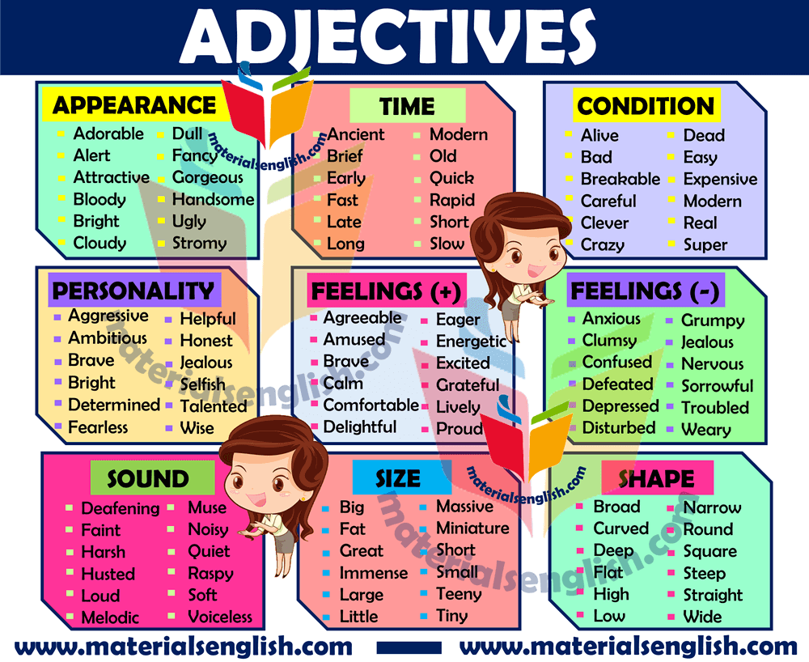 | Students' attention is drawn to the lesson.  Determines the topic and purpose of the lesson  Learners talk about favourite dayprevious lesson vocabulary  Students say different words from the picture and count one to hundred | “Good job!  Well done!” | Pictures  PPT
Middle of the lesson  Presentation part.  35 min | Ex:1 P:63  Play the recording. Ss listen and repeat chorally or individually. Check their pronunciation and intonation.  Elicit the L1 equivalents from Ss around the class.(Ss' own answers)  Direct Ss' attention to the pictures and elicit what Ss think the festivals may be like.  Read out the example and then ask various Ss around the class to say similar sentences using the adjectives given for the remaining festivals  Ex: 2 P:63  • Ask various Ss around the class to use the information in the recording to talk about each festival.  Differentiation:  «Verbal support» method is used to help Students ue new words in the text. | Students listen and repeat. Answer the question.  ANSWERS:  The Omaha Pow Wow seems to be a colourful and unusual festival.  Chinese New Year seems to be a colourful and exciting festival. It also looks artistic.  The Roswell UFO Festival seems to be a rather weird festival. The people look serious.  The Sand Sculpting Festival seems to be an artistic and unusual festival.  Nauryz seems to be a serious festival  Students listen and match the descriptions to the pictures. Then talk about festivals.  ANSWERS:  A 3  B 5  C1  D4  E6  F2 | Descriptor:  - listen and repeat.  - answer the question  Total: 2 point  Descriptor:  - listen and match the descriptions  - talk about festivals.  Total: 1 point  -Make CCQ questions  Yes / No | Cards  Student’s book  Worksheets  Student’s book
End of the lesson  5 min | Giving the hometask.  Ex: 3 P:23 wb  Self-reflection | Ss evaluate each other and encourage classmate with phrases like:  Well done! Brilliant! Good job! I like it! |  | Poster Success

Short term plan Term 3

Unit 6 Tradition and language |  | Lesson57

Teacher name:

Date:
Grade: 9 |  | Number present: | absent:
Lesson title | Reading: festivals blog
Learning objectives | 9.2.4.1 understand the main points of supported extended talk on a range of general and curricular topics  9.3.1.1 provide basic information about themselves and others at sentence level on an increasing range of general topics  9.4.5.1 deduce meaning from context in short texts on a limited range of familiar general and curricular topics
Lesson objectives | Learners will be able to:  -arrange sentences, speaker’s ideas in a logical way as they hear it in a listening  -employ subject specific vocabulary and grammar in oral discourse
Value links | "Creativity and Innovation"  Monitoring, measuring, conducting experiments and experiments ability;
Plan

Stages / Time | Teachers’ actions | Students’ actions | Assessment criteria | Resources
Beginning of the lesson  5 min | 1.Greeting.  Ask about the weather.  Warming-up  The teacher sets the lesson objectives, letting students know what to anticipate from the lesson.  Lead – In  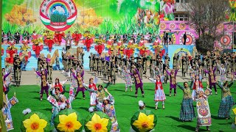 | Students' attention is drawn to the lesson.  Determines the topic and purpose of the lesson  Learners talk about favourite dayprevious lesson vocabulary  Students say different words from the picture and count one to hundred | At the organization moment T tries to award active Ss.  “Good job!  Well done!” | Pictures  PPT
Middle of the lesson  Presentation part.  35 min | Ex:1 P:64  • To introduce the topic; to predict the content of a text and to read and listen for gist  Direct Ss' attention to the pictures and read out the options explaining the meaning of any unknown words. Elicit which items Ss can see in which pictures.  Direct Ss' attention to the headings and elicit what the blog entries are about. Play the recording. Ss listen and follow the text in their books to find out.  Ex: 2 P:65  To read for specific information (multiple matching)  Read through the questions 1-5, then give Ss some time to read the blogs again and match them to the questions.  Check Ss' answers around the class.  Differentiation:  «Verbal support» method is used to help Students ue new words in the text.  Ex: 3 P:65  To read for specific information (comprehension questions)  Ask Ss to read the questions and then refer back to the text and answer them  Check Ss' answers around the class.  Ex: 4 P:65  To consolidate new vocabulary  Give Ss time to look through the texts again and find synonymous words/phrases for the words/phrases given using their dictionaries as necessary.  Check Ss' answers around the class. | Students look at the pictures in the text. Read the headings in the blog. Answer the question.  ANSWERS:  a white owl-C  dinosaurs - A  aliens - B  an ice palace - C  Students read for specific information. Match them to the questions.  ANSWERS:  1 Roswell UFO Festival  2 Sand Sculpting Festival  3 Winter Carnival  4 Sand Sculpting Festival  5 Roswell UFO Festival  Students answer the questions  ANSWERS:  1 People enjoy attending Roswell UFO Festival because it's a lot of fun. People dress up in amazing costumes, and there is a parade and a fireworks display.  2 The Winter Camival in Saranac Lake is celebrated by building a huge ice palace for the town mascot, Sara the snowy owl as well as lots of fun events, including a parade, races and treasure hunts  Students find words /phrases in the text. Use your dictionary  ANSWERS:  to continue = lasts  to give it a try = having a go  to participate take part  huge = enormous  lots of= dozens of | Descriptor:  - look at the pictures  - answer the question  Total: 2 point  Descriptor:  - read for specific information  - match them to the questions.  Total: 1 point  Descriptor:  - answer the questions  Total: 1 point  Descriptor:  - find words /phrases in the text  - Use your dictionary  Total: 2 point  -Make CCQ questions  Yes / No | Cards  Student’s book  Worksheets  Student’s book
End of the lesson  5 min | Giving the hometask.  Ex: 3 P:23 wb  Self-reflection | Ss evaluate each other and encourage classmate with phrases like:  Well done! Brilliant! Good job! I like it! |  | Poster Success

Short term plan Term 3

Unit 6 Tradition and language |  | Lesson 58

Teacher name:

Date:
Grade: 9 |  | Number present: | absent:
Lesson title | Vocabulary: celebrations
Learning objectives | 9.4.5.1 deduce meaning from context in short texts on a limited range of familiar general and curricular topics  9.5.2.1 write independently about factual and imaginary past events, activities and experiences on a range of familiar general and curricular topics
Lesson objectives | Learners will be able to:  -arrange sentences, speaker’s ideas in a logical way as they hear it in a listening  -employ subject specific vocabulary and grammar in oral discourse
Value links | "Creativity and Innovation"  Ability to find optimal ways to solve educational tasks to use new and already familiar algorithms combining, using them in solving non-standard problems
Plan

Stages / Time | Teachers’ actions | Students’ actions | Assessment criteria | Resources
Beginning of the lesson  5 min | 1.Greeting.  Ask about the weather.  Warming-up  The teacher sets the lesson objectives, letting students know what to anticipate from the lesson.  Lead – In   | Students' attention is drawn to the lesson.  Determines the topic and purpose of the lesson  Learners talk about favourite dayprevious lesson vocabulary  Students say different words from the picture and count one to hundred | At the organization moment T tries to award active Ss.  “Good job!  Well done!” | Pictures  PPT
Middle of the lesson  Presentation part.  35 min | Ex:5 P:65  To consolidate new vocabulary from a text  Give Ss some time to match the words to make phrases they have seen in the text.  Check Ss' answers.  Ex: 6 P:65  To consolidate new vocabulary  Give Ss time to complete the task and then check Ss answers.  Differentiation:  «Verbal support» method is used to help Students ue new words in the text.  Ex: 7 P:65  To learn how to form nouns from verbs  Read the theory aloud and draw Ss' attention to how the examples are formed.  Ask Ss to find examples in the text and then allow Ss time to complete the task and then check Ss' answers around the class.  Ex: 8 P:65  To distinguish between similar words  Explain the task and give Ss some time to complete it.  Check Ss' answers around the class. | Students fill the gaps.  ANSWERS:  1 sand  2 dress up  3 town  4 fireworks  5 watch  6 treasure  7 colourful  8 fancy  9 crown  10 come  Students choose the correct word.  ANSWERS:  1 place  2 include  3 lasts  4 alive  Students read the theory. Find examples in the text.  ANSWERS:  exhibition - exhibition  compete-ition - competition  celebrate-ation – celebration  Students underline the correct word.  ANSWERS:  1 annual  2 attracts  3 organising  5 prizes  4 carve  6 part | Descriptor:  - fill the gaps  Total: 2 point  Descriptor:  - choose the correct word.  Total: 1 point  Descriptor:  - read the theory  - find examples in the text  Total: 2 point  Descriptor:  - underline the correct word.  Total: 1 point  -Make CCQ questions  Yes / No | Cards  Student’s book  Worksheets  Student’s book
End of the lesson  5 min | Giving the hometask.  Ex: 3 P:23 wb  Self-reflection | Ss evaluate each other and encourage classmate with phrases like:  Well done! Brilliant! Good job! I like it! |  | Poster Success

Short term plan Term 3

Unit 6 Tradition and language |  | Lesson 59

Teacher name:

Date:
Grade: 9 |  | Number present: | absent:
Lesson title | Use of English: countable and uncountable nouns
Learning objectives | 9.5.2.1 write independently about factual and imaginary past events, activities and experiences on a range of familiar general and curricular topics  9.6.2.1 use a variety of quantifiers for countable and uncountable nouns and some noun phrases on a range of familiar general and curricular topics
Lesson objectives | Learners will be able to:  - engage effectively in a range of collaborative discussions with diverse partners  - use an increasing repertoire of countable and uncountable nouns correctly with a greater range of items before the noun;
Value links | "Creativity and Innovation"  Use of various cognitive tools, knowledge about the world be able to collect (linguistic, reading culture, information, service in the digital environment)
Plan

Stages / Time | Teachers’ actions | Students’ actions | Assessment criteria | Resources
Beginning of the lesson  5 min | 1.Greeting.  Ask about the weather.  Warming-up  The teacher sets the lesson objectives, letting students know what to anticipate from the lesson.  Lead – In  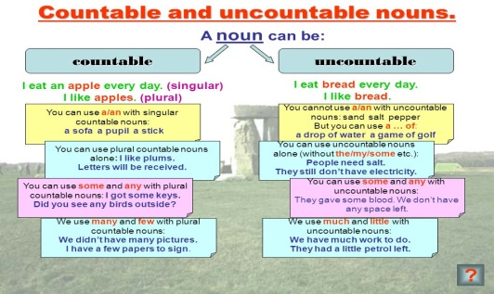 | Students' attention is drawn to the lesson.  Determines the topic and purpose of the lesson  Learners talk about favourite dayprevious lesson vocabulary  Students say different words from the picture and count one to hundred | At the organization moment T tries to award active Ss.  “Good job!  Well done!” | Pictures  PPT
Middle of the lesson  Presentation part.  35 min | Ex:1 P:66  To practise countable and uncountable nouns  Read the grammar box aloud.  Give Ss time to complete the task.  Check Ss' answers around the class. Elicit the plural forms for those nouns that have plural forms.  Ex: 2 P:66  • To practise quantifiers  Give Ss time to complete the task.  Check Ss' answers around the classroom  Differentiation:  «Verbal support» method is used to help Students ue new words in the text.  Ex: 3 P:66  To practise quantifiers  Give Ss time to complete the task.  Check Ss' answers around the classroom  Ex: 4 P:66  To present adjectives, order of adjectives and compound adjectives and practise order of adjectives  Ask Ss to read the theory box and explain any points Ss are unsure of. Then explain the task and go through the example.  Give ss time to complete the task and then check their answers, | Students read the theory. Write C(countable) or  U (uncountable). Fill a, an or some.  ANSWERS:  2 some, U  3 a, C (drinks)  4 an, C (events)  5 some, U  6 a, C (tickets)  7 some, U  8 an, C (organisations)  9 a, C (sculptures)  10 a, C (festivals)  Students choose the correct word.  ANSWERS:  1 some 2 some  3 lots of 4 lots of  5 any 6 a few  7 much 8 few  9 little 10 much  11 any 12 A lot of  Students choose the correct word  ANSWERS:  1 any 2 some 3 many  4 a lot 5 some 6 a few  7 any 8 a little 9 much  Students put the adjectives in the correct order.  ANSWERS:  2 She was wearing a lovely red wool hat.  3 Whose is this dirty old brown suitcase?  4 She's got a heavy rectangular glass picture frame on her desk.  5 He's got modern round black glasses | Descriptor:  - read the theory  - practise countable and uncountable nouns  Total: 2 point  Descriptor:  - practise quantifiers  - choose the correct word.  Total: 1 point  Descriptor:  - practise quantifiers  - choose the correct word.  Total: 1 point  Descriptor:  - put the adjectives in the correct order.  - complete the task  Total: 1 point  -Make CCQ questions  Yes / No | Cards  Student’s book  Worksheets  Student’s book
End of the lesson  5 min | Giving the hometask.  Ex: 3 P:23 wb  Self-reflection | Ss evaluate each other and encourage classmate with phrases like:  Well done! Brilliant! Good job! I like it! |  | Poster Success

Short term plan Term 3

Unit 6 Tradition and language |  | Lesson 60

Teacher name:

Date:
Grade: 9 |  | Number present: | absent:
Lesson title | Use of English: Comparative / superlative
Learning objectives | 9.5.8.1 spell most high-frequency words accurately for a limited range of general topics of familiar general topic  9.6.3.1 use a variety of compound adjectives, adjectives as participles, comparative structures indicating degree, and intensifying adjectives on a wide range of familiar general and curricular topics
Lesson objectives | Learners will be able to:  - make complex comparisons between verb/noun phrases  - proofread own and other’s works for spelling
Value links | "Creativity and Innovation"  Monitoring, measuring, conducting experiments and experiments ability;
Plan

Stages / Time | Teachers’ actions | Students’ actions | Assessment criteria | Resources
Beginning of the lesson  5 min | 1.Greeting.  Ask about the weather.  Warming-up  The teacher sets the lesson objectives, letting students know what to anticipate from the lesson.  Lead – In  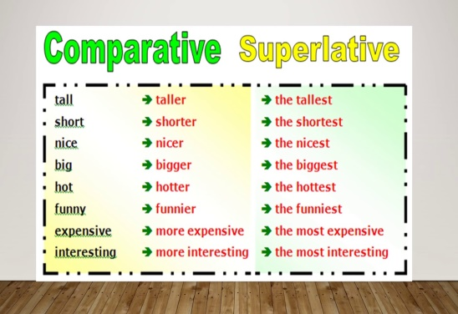 | Students' attention is drawn to the lesson.  Determines the topic and purpose of the lesson  Learners talk about favourite dayprevious lesson vocabulary  Students say different words from the picture and count one to hundred | At the organization moment T tries to award active Ss.  “Good job!  Well done!” | Pictures  PPT
Middle of the lesson  Presentation part.  35 min | Ex:5 P:67  To practise compound adjectives  Explain the task and give Ss time to complete it. .  Check Ss' answers.  Ex: 6 P:67  To practise compound adjectives  Explain the task and give Ss time to complete it.  Check Ss' answers.  Differentiation:  «Verbal support» method is used to help Students ue new words in the text.  Ex: 7 P:67  To present/practise -ing/-ed participles  Read out the theory box and explain any points Ss are unsure of.  Then explain the task and give Ss time to complete it.  Check Ss' answers.  Ex: 9 P:67  To practise comparative/superlative forms  Explain the task and give Ss time to complete it in closed pairs. Remind Ss that they will need to add extra words (e.g. more, than, the).  Check Ss' answers around the class. | Students choose the correct item.  ANSWERS:  1 a five years old  b five-year-old  2 a full-length  b full length  3 a three-day  b three days  Students complete the task.  ANSWERS:  1 world-famous  2 easy to read  3 black-and-white  4 well written  Students read the theory. Then complete each sentences with the correct adjectives.  ANSWERS:  1 interesting  2 bored  3 entertaining  4 tired  Students put the adjectives in brackets into the comparative and superlative form.  ANSWERS:  1 better than  2 more difficult than  3 the least  4 the strangest  5 the most important | Descriptor:  - choose the correct item.  -complete the task.  Total: 2 point  Descriptor:  - complete the task.  Total: 1 point  Descriptor:  - read the theory  - complete each sentences with the correct adjectives.  Total: 1 point  Descriptor:  - put the adjectives in the correct form  - complete the task  Total: 1 point  -Make CCQ questions  Yes / No | Cards  Student’s book  Worksheets  Student’s book
End of the lesson  5 min | Giving the hometask.  Ex: 3 P:23 wb  Self-reflection | Ss evaluate each other and encourage classmate with phrases like:  Well done! Brilliant! Good job! I like it! |  | Poster Success

Short term plan Term 3

Unit 6 Tradition and language |  | Lesson 61

Teacher name:

Date:
Grade: 9 |  | Number present: | absent:
Lesson title | Reading: Nauryz
Learning objectives | 9.2.1.1 understand the main points in unsupported extended talk on a wide range of general and curricular topics, including talk on a limited range of unfamiliar topics  9.3.3.1 give an opinion at sentence level on a limited range of general and curricular topics  9.4.5.1 deduce meaning from context in short texts on a limited range of familiar general and curricular topics
Lesson objectives | Learners will be able to:  -produce a speech, expressing own ideas, giving reasons and specific details to support the argument  -identify the meaning of words using contextual clues
Value links | "Creativity and Innovation"  Ability to find optimal ways to solve educational tasks to use new and already familiar algorithms combining, using them in solving non-standard problems
Plan

Stages / Time | Teachers’ actions | Students’ actions | Assessment criteria | Resources
Beginning of the lesson  5 min | 1.Greeting.  Ask about the weather.  Warming-up  The teacher sets the lesson objectives, letting students know what to anticipate from the lesson.  Lead – In   | Students' attention is drawn to the lesson.  Determines the topic and purpose of the lesson  Learners talk about favourite dayprevious lesson vocabulary  Students say different words from the picture and count one to hundred  When do Kazakhstan celebrate Nauryz? | At the organization moment T tries to award active Ss.  “Good job!  Well done!”
Middle of the lesson  Presentation part.  35 min | Ex:1a P:68  To introduce the topic  Play the recording and direct Ss' attention to the pictures.  Elicit what images are created in their minds while listening to the music, and how this makes Ss feel.  Elicit answers from Ss around the class.  Ex:1b P:68  To predict the content of the text  Elicit what, if anything, Ss know about Nauryz.  Elicit what they can guess about it from the pictures and how they think these are related to it.  Play the recording. Ss listen and follow the text in their books and find out.  Ex: 2 P:68  Ask Ss to read the questions and then give them time to read the text again and answer them.  Check Ss' answers around the class.  Differentiation:  «Verbal support» method is used to help Students ue new words in the text.  Ex: 3 P:69  To consolidate new vocabulary  Give Ss time to complete the phrases from the text. Check Ss' answers and then ask various Ss to use them to make sentences about Nauryz | Students listen to the music and look at the pictures. Answer the question.  ANSWERS:  The music reminds me of Kazakhstan. I think people are celebrating a festival. I think everyone's having a great time and they all feel happy. I feel excited  Students answer the question. Listen and read to find out.  ANSWERS:  I know that Nauryz is a spring festival. We celebrate it in Kazakhstan by deaning the house and planting flowers and trees. On this day we remember the country's history and culture and celebrate its traditions.  Students read the text again and answer the question.  ANSWERS:  1 When they saw the sun shining through a hole in the top of the yurt.  2 21st March  3 They clean their houses and plant trees and flowers to prepare for Nauryz.  4 According to legend, a holy man, Kadyr-Ata wanders the streets and only blesses a house if it is clean and the people who live there are good. His blessing brings prosperity and happiness.  5 People eat Nauryz-kozhe. It is made with seven ingredients to represent the seven days of the week and the seven virtues.  Students fill the gaps.  ANSWERS:  1 city  2 good  3 bring  4 sporting  5 traditional  6 theatrical  7 public  8 plant | Descriptor:  - listen to the music and look at the pictures  - answer the question.  Total: 2 point  Descriptor:  - answer the question.  -listen and read to find out.  Total: 1 point  Descriptor:  - read the text  - answer the question.  Total: 1 point  Descriptor:  - fill the gaps  - complete the task  Total: 1 point  -Make CCQ questions  Yes / No | Cards  Student’s book  Worksheets  Student’s book
End of the lesson  5 min | Giving the hometask.  Ex: 3 P:23 wb  Self-reflection | Ss evaluate each other and encourage classmate with phrases like:  Well done! Brilliant! Good job! I like it! |  | Poster Success

Short term plan Term 3

Unit 6 Tradition and language |  | Lesson 62

Teacher name:

Date:
Grade: 9 |  | Number present: | absent:
Lesson title | Phrasal verbs: keep
Learning objectives | 9.4.8.1 use a wide range of familiar and unfamiliar paper and digital reference resources to check meaning and extend understanding  9.6.9.1 use appropriately a wide variety of active and passive simple present and past forms and past perfect simple forms in narrative and reported speech on a wide range of familiar general and curricular topics
Lesson objectives | Learners will be able to:  - To learn phrasal verbs with keep  - To make notes and summarise the topic  - To listen for specific information
Value links | "Creativity and Innovation"  Use of various cognitive tools, knowledge about the world be able to collect (linguistic, reading culture, information, service in the digital environment)
Plan

Stages / Time | Teachers’ actions | Students’ actions | Assessment criteria | Resources
Beginning of the lesson  5 min | 1.Greeting.  Ask about the weather.  Warming-up  The teacher sets the lesson objectives, letting students know what to anticipate from the lesson.  Lead – In  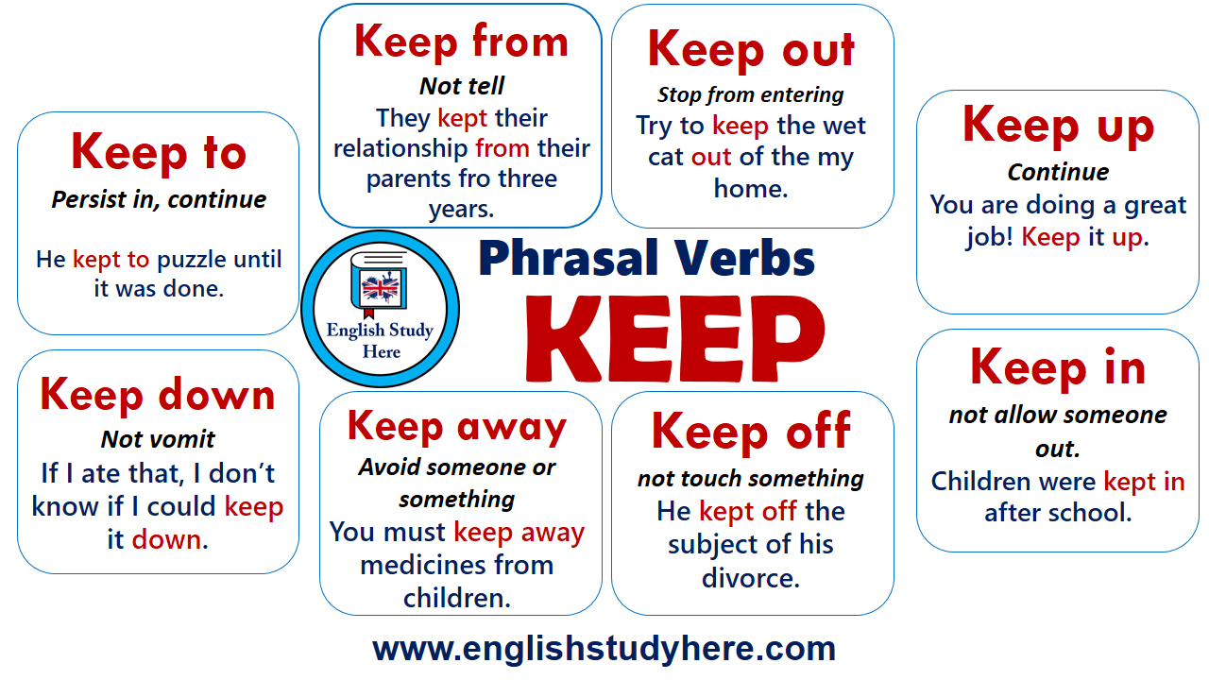 | Students' attention is drawn to the lesson.  Determines the topic and purpose of the lesson  Learners talk about favourite dayprevious lesson vocabulary  Students say different words from the picture and count one to hundred  When do Kazakhstan celebrate Nauryz? | At the organization moment T tries to award active Ss.  “Good job!  Well done!”
Middle of the lesson  Presentation part.  35 min | Ex:4 P:69  Read out the box and give Ss time to choose the correct particles for the phrasal verbs to complete the sentences.  Check Ss' answers.  Then ask Ss to choose two and draw their meanings.  Have Ss swap drawings and guess which phrasal verbs they are of  Ex:5 P:69  Write the headings on the board and ask Ss to copy them into their notebooks.  Elicit one or two notes to write under each heading, and then give Ss time to look through the text and make more notes under each heading.  Ask various Ss to use their notes to present Nauryz  Ex: 6 P:69  Explain the task.  Ask Ss to read the statements to get an idea about what they will listen to and what answers they have to listen for. Play the recording and Ss complete the task.  Check Ss' answers.  Differentiation:  «Verbal support» method is used to help Students ue new words in the text.  Ex: 7 P:69  Initiate a class discussion about Nauryz and why it is important.  Give Ss some time to write a few sentences about it.  Ask various Ss around the class to read out their sentences to the class. | Students choose the correct particle. Choose two and draw their meaning.  ANSWERS:  1 off  2 on  3 up  Students make notes under the heading. Use your notes to present the celebrations of Nauryz to the class.  ANSWERS:  Name: Nauryz  Time: 21st March for three days  Traditions: Planting trees and flowers and cleaning houses, yurts in city squares, theatrical performances, music concerts, sporting events with horses, special dish called Nauryz-kozhe  Superstitions: Kadyr-Ata only blesses houses with prosperity and happiness if they are clean  Reasons: celebrate the coming of spring and remember the country's history, traditions and culture  Nauryz takes place on 21st March and lasts for three days.  Students listen two to friends talking about superstitions. Mark the statements.  ANSWERS:  1 F  2 F  3 F  4 T  5 T  Students in three minutes, write a few sentences on the topic. Read them to the class.  ANSWERS:  I think Nauryz is important because it connects us to our past. The traditions started with the nomads who lived in yurts. Today we continue the traditions and we celebrate our culture and history. | Descriptor:  - choose the correct particle  - choose two and draw their meaning.  Total: 2 point  Descriptor:  - make notes under the heading  - use your notes to present the celebrations  Total: 1 point  Descriptor:  - listen two to friends talking about superstitions  - mark the statements.  Total: 1 point  Descriptor:  - in three minutes, write a few sentences  - read them to the class.  Total: 1 point  -Make CCQ questions  Yes / No | Student’s book
End of the lesson  5 min | Giving the hometask.  Ex: 3 P:23 wb  Self-reflection | Ss evaluate each other and encourage classmate with phrases like:  Well done! Brilliant! Good job! I like it! |  | Poster Success

Short term plan Term 3

Unit 6 Tradition and language |  | Lesson 63

Teacher name:

Date:
Grade: 9 |  | Number present: | absent:
Lesson title | Everyday English: Buying a gift
Learning objectives | 9.3.6.1 link comments with flexibility to what others say at sentence and discourse level in pair, group and whole class exchanges  9.4.2.1 understand specific information and detail in extended texts on a growing range of familiar general and curricular topics, and some unfamiliar topics
Lesson objectives | Learners will be able to:  - To present situational language associated with buying a gift  - To listen and read for gist
Value links | "Creativity and Innovation"  Monitoring, measuring, conducting experiments and experiments  ability;
Plan

Stages / Time | Teachers’ actions | Students’ actions | Assessment criteria | Resources
Beginning of the lesson  5 min | 1.Greeting.  Ask about the weather.  Warming-up  The teacher sets the lesson objectives, letting students know what to anticipate from the lesson.  Lead – In   | Students' attention is drawn to the lesson.  Determines the topic and purpose of the lesson  Learners talk about favourite dayprevious lesson vocabulary  Students say different words from the picture and count one to hundred | At the organization moment T tries to award active Ss.  “Good job!  Well done!” | Pictures  PPT
Middle of the lesson  Presentation part.  35 min | Ex:1 P:70  Play the recording with pauses for Ss to repeat individually.  Check Ss' pronunciation, intonation and use of stress rhythm.  Ex:2 P:70  Elicit the topic of the dialogue (buying a friend a gift).  Play the recording. Ss listen and follow the dialogue in their books to check.  Ex: 3a P:70  Read out the questions in the rubric and allow Ss some time to read through the dialogue again and find the answers.  Check Ss' answers.  Differentiation:  «Verbal support» method is used to help Students ue new words in the text.  Ex: 3b P:70  Refer Ss to the underlined modal verbs in the dialogue and elicit what they express from Ss around the class.  Ex: 4 P:70  Read out the phrases and give Ss time to find alternative phrases in the dialogue that have a similar meaning.  Check Ss' answers. | Students listen and repeat. Pay attention to the stress rhythm.  ANSWERS:  Students own answer  Students the sentences above are from a dialogue between two friends. Listen, read and check  ANSWERS:  The dialogue is about two people discussing what gift to buy for someone  Students read the dialogue. Answer the question.  ANSWERS:  Katie suggests they buy Judy a book.  Katie and June finally decide to get Judy a C  Students identify the underlined modal verbs in the dialogue and elicit what they express  ANSWERS:  can - ability  shall - suggestion  could – possibility  Students find sentences in the dialogue.  ANSWERS:  How's it going? = What are you up to?  I'm really looking forward to it. I can hardly wait!  She's difficult to please. = She's very fussy.  She doesn't really like reading. She's not too keen on reading.  Oh, I understand. = Oh, I see. | Descriptor:  - listen and repeat.  - use of stress rhythm.  Total: 2 point  Descriptor:  - listen, read and check  Total: 1 point  Descriptor:  - read the dialogue.  - answer the question.  Total: 1 point  Descriptor:  - identify the underlined modal verbs  -elicit what they express  Total: 1 point  -Make CCQ questions  Yes / No | Cards  Student’s book  Worksheets  Student’s book
End of the lesson  5 min | Giving the hometask.  Ex: 3 P:23 wb  Self-reflection | Ss evaluate each other and encourage classmate with phrases like:  Well done! Brilliant! Good job! I like it! |  | Poster Success

Short term plan Term 3

Unit 6 Tradition and language |  | Lesson 64

School

Teacher name:

Date:
Grade: 9 |  | Number present: | absent:
Lesson title | Across cultures: Eco –Festivals  Summative assessment for the unit 6
Learning objectives | 9.4.2.1 understand specific information and detail in extended texts on a growing range of familiar general and curricular topics, and some unfamiliar topics  9.5.3.1 write with grammatical accuracy on a range of familiar general and curricular topics
Lesson objectives | Learners will be able to:  -To introduce the topic and predict the content of the text.  -To read for specific information (comprehension questions)
Value links | "Creativity and Innovation"  Ability to find optimal ways to solve educational tasks to use new and already familiar algorithms combining, using them in solving non-standard problems
Plan

Stages / Time | Teachers’ actions | Students’ actions | Assessment criteria | Resources
Beginning of the lesson  5 min | 1.Greeting.  Ask about the weather.  Warming-up  The teacher sets the lesson objectives, letting students know what to anticipate from the lesson.  Lead – In   | Students' attention is drawn to the lesson.  Determines the topic and purpose of the lesson  Learners talk about favourite dayprevious lesson vocabular  Students say different words from the picture and count one to hundred | At the organization moment T tries to award active Ss.  “Good job!  Well done!” | Pictures  PPT
Middle of the lesson  Presentation part.  35 min | Ex:1 P:71  Direct Ss' attention to the pictures and the headings and elicit what Ss think people can do at eco- festivals.  Play the recording. Ss listen and follow the text in their books and find out.  Ex:2 P:71  • Give Ss time to read the text again and answer the questions.  Check Ss' answers.  Differentiation:  «Verbal support» method is used to help Students ue new words in the text.  Ex: 3 P:71  • Read out the two sentences and elicit which one best summarises the main idea of eco-festivals.  Ex: 4 P:71  • Explain the task and give Ss some time to complete it.  Check Ss' answers around the class. | Students read the title and look at the pictures. Answer the question.  ANSWERS:  People do various activities including: learn how to grow their own food and reduce waste; listen to talks; go on nature walks; do yoga; watch live music and dance; sleep in tents; listen to presentations; take part in demonstrations; watch live entertainment; go to workshops and learn about saving energy and water, recycling, how to make their city environmentally-friendly  Students read the text again and answer the question.  ANSWERS:  1 Earth Fest takes place over three days in June every year.  2 400  3 5-20 years old  4 They can leam about saving energy and water, recycling and how to make their city environmentally- friendly.  Students answer the question.  ANSWERS:  Learn how to help our world and have a good time.  Students choose the correct prepositions  ANSWERS:  1 about, of  2 for  3 on  4 with | Descriptor:  - read the title  - answer the question  Total: 2 point  Descriptor:  - read the text  - answer the question.  Total: 1 point  Descriptor:  - answer the question.  Total: 1 point  Descriptor:  - choose the correct prepositions  Total: 1 point  -Make CCQ questions  Yes / No | Cards  Student’s book  Worksheets  Student’s book
End of the lesson  5 min | Giving the hometask.  Ex: 3 P:23 wb  Self-reflection | Ss evaluate each other and encourage classmate with phrases like:  Well done! Brilliant! Good job! I like it! |  | Poster Success

Short term plan Term 3

Unit 6 Tradition and language |  | Lesson 65

Teacher name:

Date:
Grade: 9 |  | Number present: | absent:
Lesson title | Across the curriculum: Remembrance Day
Learning objectives | 9.3.1.1 use formal and informal language registers in their talk on a range of general and curricular topics  9.4.2.1 understand specific information and detail in extended texts on a growing range of familiar general and curricular topics, and some unfamiliar topics
Lesson objectives | Learners will be able to:  -To introduce the topic and to predict the content of a text  -To read for gist and comprehension  -To consolidate new vocabulary
Value links | "Creativity and Innovation"  Use of various cognitive tools, knowledge about the world be able to collect (linguistic, reading culture, information, service in the digital environment)
Plan

Stages / Time | Teachers’ actions | Students’ actions | Assessment criteria | Resources
Beginning of the lesson  5 min | 1.Greeting.  Ask about the weather.  Warming-up  The teacher sets the lesson objectives, letting students know what to anticipate from the lesson.  Lead – In   | Students' attention is drawn to the lesson.  Determines the topic and purpose of the lesson  Learners talk about favourite dayprevious lesson vocabulary  Students say different words from the picture and count one to hundred | At the organization moment T tries to award active Ss.  “Good job!  Well done!” | Pictures  PPT
Middle of the lesson  Presentation part.  35 min | Ex:1 P:72  Read out the questions in the rubric and brainstorm with the class for answers.  Play the recording. Ss listen and find out about Remembrance Day in Australia.  Ex:2 P:72  Go through the Study Skills box with Ss and explain that this advice will help Ss to complete the task successfully.  Ask Ss to read the headings aloud and explain/ elicit any unknown words.  Give Ss time to read the text and match the headings to the paragraphs.  Check Ss' answers.  Ex: 3 P:72  .Refer Ss to the Check these words box and explain/ elicit the meanings of the words or ask Ss to use the Word List or their dictionaries to look them up.  Give Ss time to complete the task, and then check Ss' answers.  Ex: 4 P:72  Read out the words/phrases in the list and then ask various Ss around the class to explain how these relate to Remembrance Day.  Differentiation:  «Verbal support» method is used to help Students ue new words in the text. | Students answer the question. Listen, read and check.  ANSWERS:  Annual events that are important for a person to remember birthdays, anniversaries of important events in their life.  Annual events that are important for a society to remember = religious holidays, national holidays, national events, etc.  Australians remember soldiers that have died in all wars since WWI  Students read the text again and match the headings to the paragraph.  ANSWERS:  1 C An annual event  2 D A solemn commemoration  3 A Flowers to honour  Students complete the sentences with the words from the box.  ANSWERS:  1 honour  2 fighting, war  3 memorial, battlefields  4 silence  Students use the text to make sentences.  ANSWERS:  People around the world celebrate Remembrance Day on 11th November.  A musician plays The Last Post at the beginning of a two- minute silence.  A bugler plays the music at a Remembrance Day ceremony.  Many people died fighting on the battlefields during World War | Descriptor:  - answer the question  - listen, read and check.  Total: 2 point  Descriptor:  - read the text  - match the headings to the paragraph.  Total: 2 point  Descriptor:  - complete the sentences  Total: 1 point  Descriptor:  - use the text to make sentences  Total: 1 point  -Make CCQ questions  Yes / No | Cards  Student’s book  Worksheets  Student’s book
End of the lesson  5 min | Giving the hometask.  Ex: 3 P:23 wb  Self-reflection | Ss evaluate each other and encourage classmate with phrases like:  Well done! Brilliant! Good job! I like it! |  | Poster Success

Short term plan Term 3

Unit 6 Tradition and language |  | Lesson 66

Teacher name:

Date:
Grade: 9 |  | Number present: | absent:
Lesson title | Writing: Quebec winter carnival
Learning objectives | 9.4.5.1 deduce meaning from context in extended texts on a range of familiar general and curricular topics;  9.5.2.1 write independently about factual and imaginary past and future events, activities and experiences on a wide range of familiar general and curricular topics
Lesson objectives | Learners will be able to:  -To read for gist and comprehension  -To read for cohesion and coherence; to learn to use descriptive language
Value links | "Creativity and Innovation"  Monitoring, measuring, conducting experiments and experiments  ability;
Plan

Stages / Time | Teachers’ actions | Students’ actions | Assessment criteria | Resources
Beginning of the lesson  5 min | 1.Greeting.  Ask about the weather.  Warming-up  The teacher sets the lesson objectives, letting students know what to anticipate from the lesson.  Lead – In   | Students' attention is drawn to the lesson.  Determines the topic and purpose of the lesson  Learners talk about favourite dayprevious lesson vocabulary  Students say different words from the picture and count one to hundred | At the organization moment T tries to award active Ss.  “Good job!  Well done!” | Pictures  PPT
Middle of the lesson  Presentation part.  35 min | Ex:1 P:73  Read out the Writing Tip and discuss it with Ss.  Read the headings aloud and then give Ss time to read the text and match them to the paragraphs.  Check Ss' answers.  Ex:2 P:73  Go through the Study Skills box and explain/elicit the meanings of the adjectives in the rubric.  Give Ss time to read the text and complete the task and then check Ss' answers.  Ex: 3 P:73  .Read the rubric aloud and ask Ss to identify words that tell them for who and what they have to write.  Check Ss' answers.  Differentiation:  «Verbal support» method is used to help Students ue new words in the text. | Students read the article and match the paragraphs to the headings.  ANSWERS:  A 4  B 3  C I  D 2  Students read the Study Skills box. Then fill in the gaps.  ANSWERS:  1 annual  2 amazing  3 cheerful  4 decorated  5 traditional  6 long  7 unforgettable  Students read the rubric and underline the key words. Answer the question.  ANSWERS:  Key words: magazine for teenagers, article, celebration in your country  I am going to write a descriptive article about an event. I am writing it for teenagers to read | Descriptor:  - read the article  - match the paragraphs  Total: 2 point  Descriptor:  - read the Study Skills box.  - fill in the gaps.  Total: 2 point  Descriptor:  - read the rubric  - underline the key words  Total: 1 point  -Make CCQ questions  Yes / No | Cards  Student’s book  Worksheets  Student’s book
End of the lesson  5 min | Giving the hometask.  Ex: 3 P:23 wb  Self-reflection | Ss evaluate each other and encourage classmate with phrases like:  Well done! Brilliant! Good job! I like it! |  | Poster Success

Short term plan Term 3

Unit 6 Tradition and language |  | Lesson 67

Teacher name:

Date:
Grade: 9 |  | Number present: | absent:
Lesson title | Edutainment
Learning objectives | 9.6.3.1 use a variety of compound adjectives, adjectives as participles, comparative structures indicating degree, and intensifying adjectives on a wide range of familiar general and curricular topics  9.3.3.1 explain and justify their own point of view on a range of general and curricular topics
Lesson objectives | Learners will be able to:  - To talk about reasons to celebrate traditional festivals  - To consolidate and test knowledge and vocabulary from the module
Value links | "Creativity and Innovation"  Ability to find optimal ways to solve educational tasks to use new and already familiar algorithms combining, using them in solving non-standard problems
Plan

Stages / Time | Teachers’ actions | Students’ actions | Assessment criteria | Resources
Beginning of the lesson  5 min | 1.Greeting.  Ask about the weather.  Warming-up  The teacher sets the lesson objectives, letting students know what to anticipate from the lesson.  Lead – In   | Students' attention is drawn to the lesson.  Determines the topic and purpose of the lesson  Learners talk about favourite dayprevious lesson vocabulary  Students say different words from the picture and count one to hundred | At the organization moment T tries to award active Ss.  “Good job!  Well done!” | Pictures  PPT
Middle of the lesson  Presentation part.  35 min | Ex:1 P:74  • Ask Ss to read the list and choose the correct items. Check Ss' answers and then ask Ss to discuss which of them are reasons to celebrate traditional festivals. Ask various Ss to tell the class.  Ex:2 P:74  Ask Ss to discuss the question in pairs using the list and their own ideas. Ask various Ss to tell the class.  Ex: 3 P:74  Explain the task and ask Ss to work in pairs or small groups and create a festival and make notes under the headings. Then ask various Ss to present their festival to the class.  Differentiation:  «Verbal support» method is used to help Students ue new words in the text.  Ex: 4 P:74  Give Ss time to complete the quiz referring back to the module as necessary.  Check Ss' answers and elicit the correct answers for the false items. | Students look at the list. Choose the correct item.  ANSWERS:  1 shouldn't  2 can  3 should  4 can  5 will  6 might  7 can  Students answer the question. Use the list to tell the class.  ANSWERS:  I think it is important to keep our traditions to remember our history and culture, to respect the customs of a group of people or a place and to learn traditional songs and dances. I think this helps people to share a common bond and helps a community to come together  Students create your own festival  ANSWERS:  Name: Local History Day  Place: every village/town/city  Time: 1st June every year  Reason: to celebrate the history of the place where people live  Activities: exhibitions of old photos and important events that have happened, a parade, a market with food stalls and a fun fair, races and competitions, fireworks display - people have fun and communities come together  Students go through Module 6 and write true or false  ANSWERS:  1T  2 F (It's in the USA.)  3 T  4 F (Kadyr-Ata is a legendary holy man.)  5T  6 F (It lasts three days.)  7 F (It takes place all over Kazakhstan.)  8T 9T 10 T | Descriptor:  - look at the list  - choose the correct item  Total: 2 point  Descriptor:  - answer the question.  - use the list to tell  Total: 2 point  Descriptor:  - create your own festival  Total: 1 point  Descriptor:  - go through Module 6  - write true or false  Total: 1 point  -Make CCQ questions  Yes / No | Cards  Student’s book  Worksheets  Student’s book
End of the lesson  5 min | Giving the hometask.  Ex: 3 P:23 wb  Self-reflection | Ss evaluate each other and encourage classmate with phrases like:  Well done! Brilliant! Good job! I like it! |  | Poster Success
Short term plan Term 3

Unit 7 Music and films. |  | Lesson 68

School

Teacher name:

Date:
Grade: 9 |  | Number present: | absent:
Lesson title | Vocabulary: types of films
Learning objectives | 9.2.6.1 deduce meaning from context in unsupported extended talk on a wide range of general and curricular topics, including talk on a limited range of unfamiliar topics  9.4.2.1 understand specific information and detail in extended texts on a growing range of familiar general and curricular topics, and some unfamiliar topics
Lesson objectives | Learners will be able to:  - To present vocabulary for types of films  - To read for gist
Value links | "Creativity and Innovation"  Use of various cognitive tools, knowledge about the world be able to collect (linguistic, reading culture, information, service in the digital environment)
Plan

Stages / Time | Teachers’ actions | Students’ actions | Assessment criteria | Resources
Beginning of the lesson  5 min | 1.Greeting.  Ask about the weather.  Warming-up  The teacher sets the lesson objectives, letting students know what to anticipate from the lesson.  Lead – In   | Students' attention is drawn to the lesson.  Determines the topic and purpose of the lesson  Learners talk about favourite dayprevious lesson vocabulary  Students say different words from the picture and count one to hundred | At the organization moment T tries to award active Ss.  “Good job!  Well done!” | Pictures  PPT
Middle of the lesson  Presentation part.  35 min | Ex:1 P:75  Go through the list of words and explain/elicit the meanings of any unknown words.  Then play the recording for Ss to listen and repeat chorally and/or individually.  Check Ss' pronunciation and intonation  Ex:2 P:75  Ask Ss to read the reviews and then give Ss time to match them to the film posters.  Check Ss' answers and then elicit what type of film each one is.  Ex: 3 P:75  Ask Ss to discuss in pairs which films they have/ haven't seen and recommend a film to each other.  Monitor the activity around the class and then ask Ss to say whether they were persuaded or not.  Differentiation:  «Verbal support» method is used to help Students ue new words in the text. | Students listen and repeat.  ANSWERS:  Students own answer  Students match the reviews to the film posters.  ANSWERS:  1 B 2 D 3 C 4 A  1 science fiction  2 musical  3 animation  4 action/adventure  Students answer the question. Discuss in pairs.  ANSWERS:  Star Wars: The Force Awakens has broken box office records. It's a must-see.  Have you seen Frozen? It's the perfect film for the whole family to enjoy.  If you haven't seen in the Heart of the Sea yet, make sure your do. It's an incredible true story of human courage | Descriptor:  - listen and repeat.  Total: 2 point  Descriptor:  - read the reviews  - match the reviews to the film  Total: 2 point  Descriptor:  - answer the question.  - discuss in pairs  Total: 1 point  -Make CCQ questions  Yes / No | Student’s book
End of the lesson  5 min | Giving the hometask.  Ex: 3 P:23 wb  Self-reflectio | Ss evaluate each other and encourage classmate with phrases like:  Well done! Brilliant! Good job! I like it! |  | Poster Success

Short term plan Term 3

Unit 7 Music and films. |  | Lesson 69

Teacher name:

Date:
Grade: 9 |  | Number present: | absent:
Lesson title | Reading: The Eagle Huntress
Learning objectives | 9.4.4.1 read a range of extended fiction and non-fiction texts on familiar and unfamiliar general and curricular topics;  9.3.2.1 ask complex questions to get information about a wide range of general and curricular topics
Lesson objectives | Learners will be able to:  - To read for cohesion and coherence (missing sentences)  - To consolidate comprehension of a text  - To practise relatives and wishes
Value links | "Independence and patriotism",  To the past, present and future of the people understand the relevance
Plan

Stages / Time | Teachers’ actions | Students’ actions | Assessment criteria | Resources
Beginning of the lesson  5 min | 1.Greeting.  Ask about the weather.  Warming-up  The teacher sets the lesson objectives, letting students know what to anticipate from the lesson.  Lead – In   | Students' attention is drawn to the lesson.  Determines the topic and purpose of the lesson  Learners talk about favourite dayprevious lesson vocabulary  Students say different words from the picture and count one to hundred | At the organization moment T tries to award active Ss.  “Good job!  Well done!” | Pictures  PPT
Middle of the lesson  Presentation part.  35 min | Ex:1 P:76  Ask Ss to look at the picture and the title and then elicit what type of film 5s think it is.  Give Ss time to read the text and find out  Ex:2 P:76  Ask Ss to read the sentences in the list and then read the text and match the sentences to the gaps. Check Ss' answers.  Refer Ss to the Word List to look up the words in the Check these words box.  Play the video for Ss and elicit their comments  Ex: 3 P:77  Give Ss time to read through the text again if necessary and answer the questions.  Check Ss answers around the class  Differentiation:  «Verbal support» method is used to help Students ue new words in the text.  Ex: 4 P:77  • Explain the task and give Ss time to complete the task.  Elicit answers from Ss around the class. | Students look at the title and the picture. Answer the question. Read through to find out.  ANSWERS:  The film is about a young Kazakh girl who breaks with tradition and becomes a female eagle hunter  Students choose from sentences the one that fits each gap. Listen, read and check.  ANSWERS:  1 E  2 G  3 A  4 D  5 B  6 F  Students answer the question in your own language.  ANSWERS:  1 Usually it is a skill that fathers teach (to) their sons.  2 He saw some photos online of Aisholpan training.  3 Filming was difficult because of the snow and the dust and the lack of electricity  Students answer the question. Use if, only or relative pronouns.  ANSWERS:  1 If only she could be an eagle hunter. Her wish came true when she started training.  2 Otto Bell was the person who got inspired by her. His hard work paid off when the final film captured the stunning scenery. | Descriptor:  - look at the title  - answer the question  Total: 2 point  Descriptor:  - read the text  - match the sentences to the gaps  Total: 2 point  Descriptor:  - answer the question.  Total: 1 point  Descriptor:  - answer the question.  - use if, only or relative pronouns  Total: 1 point  -Make CCQ questions  Yes / No | Student’s book
End of the lesson  5 min | Giving the hometask.  Ex: 3 P:23 wb  Self-reflectio | Ss evaluate each other and encourage classmate with phrases like:  Well done! Brilliant! Good job! I like it! |  | Poster Success

Short term plan Term 3

Unit 7 Music and films. |  | Lesson 70

Teacher name:

Date:
Grade: 9 |  | Number present: | absent:
Lesson title | Vocabulary: films
Learning objectives | 9.3.3.1 explain and justify their own point of view on a range of general and curricular topics  9.5.3.1 write with grammatical accuracy on a range of familiar general and curricular topics  9.6.1.1 use a growing variety of abstract compound nouns and complex noun phrases on a range of familiar general and curricular topics;
Lesson objectives | Learners will be able to:  - To present/revise vocabulary relating to films  -To learn/practise prepositional phrases  -To talk about the making of a film
Value links | "Independence and patriotism",  Assessment of the importance of loyalty to the motherland, the history of the country respect culture
Plan

Stages / Time | Teachers’ actions | Students’ actions | Assessment criteria | Resources
Beginning of the lesson  3 min | 1.Greeting.  Ask about the weather.  Warming-up  The teacher sets the lesson objectives, letting students know what to anticipate from the lesson.  Lead – In  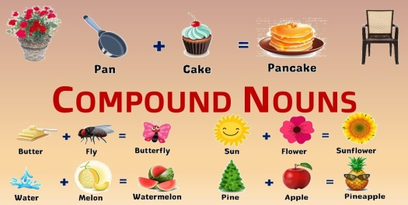 | Students' attention is drawn to the lesson.  Determines the topic and purpose of the lesson  Learners talk about favourite dayprevious lesson vocabulary  Students say different words from the picture and count one to hundred | At the organization moment T tries to award active Ss.  “Good job!  Well done!” | Pictures  PPT
Middle of the lesson  Presentation part.  35 min | Ex:5 P:77  Give Ss time to complete the sentences with the words in the list. Have Ss check their answers in their dictionaries  Ex:6 P:77  Ask Ss to talk about their favourite films using both, either, neither, all.  Ask various Ss to tell the class  Ex: 7 P:77  Give Ss time to read the sentences and choose the correct prepositions.  Check Ss answers.  Differentiation:  «Verbal support» method is used to help Students ue new words in the text.  Ex: 8 P:77  Ask Ss to read the theory box and then give them time to form compound nouns using the words in the boxes.  Check Ss' answers.  Then give Ss time to use them in complex sentences following the example. | Students fill the gaps.  ANSWERS:  1 true  2 aerial  3 closing  4 praised  5 strong  Students think of your favourite films. Use both, either, neither, all to talk them.  ANSWERS:  I really like Guardians of the Galaxy and Guardians of the Galaxy Vol 2. Both films star Chris Pratt. You can watch them either on DVD or online. Neither film will disappoint you especially if you like science fiction. All the Marvel Studios films are entertaining  Students choose the correct item. Check in your dictionary.  ANSWERS:  1 for  2 off  3 of  4 with  5 on  6 of  7 on  8 agains  Students read the theory. Then, form compound nouns using the words below. Use them in complex sentences.  ANSWERS:  swimming pool  birthday  bedroom  cardboard  whitewash  haircut  starlight | Descriptor:  - fill the gaps  - complete the task  Total: 2 point  Descriptor:  - think of your favourite films  - talk about their favourite films  Total: 2 point  Descriptor:  - choose the correct item  - check in your dictionary  Total: 1 point  ,  Descriptor:  - read the theory  - form compound nouns  Total: 1 point  -Make CCQ questions  Yes / No | Cards  Student’s book  Worksheets  Student’s book
End of the lesson  5 min | Giving the hometask.  Ex: 3 P:23 wb  Self-reflectio | Ss evaluate each other and encourage classmate with phrases like:  Well done! Brilliant! Good job! I like it! |  | Poster Success

Short term plan Term 3

Unit 7 Music and films. |  | Lesson 71

School

Teacher name:

Date:
Grade: 9 |  | Number present: | absent:
Lesson title | Use of English: relatives
Learning objectives | 9.5.4.1 use style and register to achieve appropriate degree of formality in a growing variety of written genres on a range of general and curricular topics  9.6.6.1 use a wide variety of relative, demonstrative, indefinite, quantitative]of pronouns and reflexive pronoun structures on a wide range of familiar general and curricular topics
Lesson objectives | Learners will be able to:  - To present relatives  -To practise relative clauses  -To present and practise some/any/no/every & compounds
Value links | "Independence and patriotism"  Respect the state symbols of Kazakhstan, understand the meaning of public holidays
Plan

Stages / Time | Teachers’ actions | Students’ actions | Assessment criteria | Resources
Beginning of the lesson  5 min | 1.Greeting.  Ask about the weather.  Warming-up  The teacher sets the lesson objectives, letting students know what to anticipate from the lesson.  Lead – In  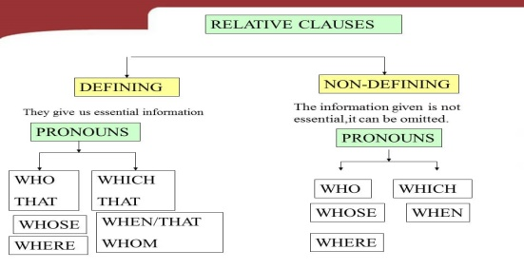 | Students' attention is drawn to the lesson.  Determines the topic and purpose of the lesson  Learners talk about favourite dayprevious lesson vocabulary  Students say different words from the picture and count one to hundred | At the organization moment T tries to award active Ss.  “Good job!  Well done!” | Pictures  PPT
Middle of the lesson  Presentation part.  35 min | Ex:1 P:78  Explain that we use relatives (who, which, whose, when, where, why) to introduce relative clauses to identify the noun in the main clause.  Explain that we use who/that instead of subject pronouns to talk about people; we use which/that to talk about objects or animals; we use whose instead of possessive adjectives to talk about possession and we use where/when/why to talk about place/time/reason.  Explain the difference between defining and non- defining relative clauses.g. defining = give essential information, non-defining = give extra  Ex:2 P:78  Explain the task.  Give Ss time to complete the task and then check Ss' answers.  Ex: 3 P:78  • Explain the task.  Give Ss time to complete it.  Check Ss' answers  Differentiation:  «Verbal support» method is used to help Students ue new words in the text.  Ex: 4 P:78  Read the table aloud and ask Ss to copy it into their notebooks.  Explain the task and give Ss time to complete it.  Check Ss' answers around the class. | Students read the theory. Say the examples in your language.  ANSWERS:  Students own answer.  Students fill the gaps. Answer the question. Rewrite them using commas where needed.  ANSWERS:  1 isn't that the café where they filmed Amelie? (defining)  2 The advert which won the award was filmed near my house. (defining)  3 Ben is the boy whose mother is an actress. (defining)  4 That is the actor who starred in The Tourist. (defining)  5 George Clooney, who is in the film Gravity, is very handsome. (non-defining)  6 Mr Harris, who came up with the idea for the shop, is Canadian. (non-defining)  7 The photographs which I took in Hollywood have  been developed. (delining) 8 August is the month when she was born. (defining)  9 Amy, who works at the advertising agency, is my cousin. (non-defining)  10 That's the reason why he loves comedy films so much. (defining)  Students join the sentences. Answer the question.  ANSWERS:  1 Alfred Hitchcock, who was a film director, made over fifty films. (non-defining)  2 Mark, whose father is shooting the advertisement, phoned me today. (non-defining)  3 That is the shop where they sell autographed memorabilia. (defining)  4 I met a girl last night whose mother is a well-known actress. (defining)  5 My mum gave me her wedding dress, which belonged to her mother. (non-defining)  6 Emily, whose mum is a singer, invited me to a private concert. (non-defining)  7 Brad Pitt, who starred in Ocean's Eleven, is a philanthropist. (non-defining)  8 That's the restaurant where all the dishes are named after actors. (defining)  Students read the table. Choose the correct item.  ANSWERS:  1 any  2 Everyone  3 something  4 no  5 somewhere | Descriptor:  - read the theory  - say the examples in your language  Total: 2 point    Descriptor:  - fill the gaps  - rewrite them using commas where needed  Total: 2 point  Descriptor:  - join the sentences  - answer the question.  Total: 1 point  Descriptor:  - read the table  - choose the correct item  Total: 1 point  -Make CCQ questions  Yes / No | Cards  Student’s book  Worksheets  Student’s book
End of the lesson  5 min | Giving the hometask.  Ex: 3 P:23 wb  Self-reflectio | Ss evaluate each other and encourage classmate with phrases like:  Well done! Brilliant! Good job! I like it! |  | Poster Success

Short term plan Term 3

Unit 7 Music and films. |  | Lesson 72

School

Teacher name:

Date:
Grade: 9 |  | Number present: | absent:
Lesson title | Use of English: Demonstratives
Learning objectives | 9.5.4.1 use style and register to achieve appropriate degree of formality in a growing variety of written genres on a range of general and curricular topics  9.6.6.1 use a wide variety of relative, demonstrative, indefinite, quantitative]of pronouns and reflexive pronoun structures on a wide range of familiar general and curricular topics
Lesson objectives | Learners will be able to:  - To practise some/any/no/every & compounds  - To present reflexive pronouns  - To practise demonstratives
Value links | "Independence and patriotism",  To the past, present and future of the people understand the relevance
Plan

Stages / Time | Teachers’ actions | Students’ actions | Assessment criteria | Resources
Beginning of the lesson  5 min | 1.Greeting.  Ask about the weather.  Warming-up  The teacher sets the lesson objectives, letting students know what to anticipate from the lesson.  Lead – In  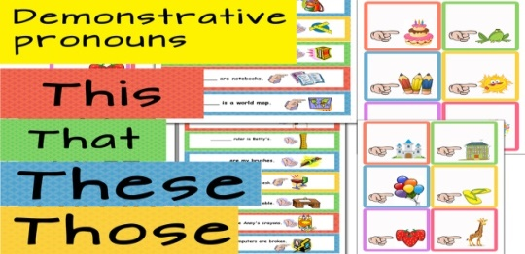 | Students' attention is drawn to the lesson.  Determines the topic and purpose of the lesson  Learners talk about favourite dayprevious lesson vocabulary  Students say different words from the picture and count one to hundred | At the organization moment T tries to award active Ss.  “Good job!  Well done!” | Pictures  PPT
Middle of the lesson  Presentation part.  35 min | Ex:5 P:79  Explain the task and give Ss time to complete it.  Check Ss' answers around the class.  Ex:6 P:79  Explain the task and give Ss time to complete it.  Check Ss' answers around the class  Ex: 7 P:79  Explain the task and give Ss time to complete it. Then elicit which words we use for things near/far from us.  Differentiation:  «Verbal support» method is used to help Students ue new words in the t  Ex: 8 P:79  Read out the box and go through the theory. Explain any points Ss are unsure of  Ex: 9 P:79  Explain the task and read out the example.  Give Ss time to complete the task.  Check Ss' answers around the class | Students complete the exchanges with the correct word from the table.  ANSWERS:  1 anywhere  2 somewhere  3 someone  4 anyone, no one/nobody  5 everywhere  Students fill the gaps..  ANSWERS:  1 everything  2 some  3 anything  4 Everyone  5 every  6 nothing  Students complete the sentences.  ANSWERS:  1 those  2 This  3 that  4 these  this/these-near  that/those-far  Students read the theory  ANSWERS:  Students own answer.  Students fill in the correct reflexive pronouns.  ANSWERS:  2 himself  3 yourself  4 herself  5 ourselves  6 themselves | Descriptor:  - complete the exchanges with the correct word  - complete the task  Total: 2 point  Descriptor:  - fill the gaps  - complete the task  Total: 2 point  Descriptor:  - complete the sentences.  Total: 1 point  Descriptor:  - read the theory  Total: 1 point  Descriptor:  - fill in the correct reflexive pronouns  - complete the task  Total: 2 point  -Make CCQ questions  Yes / No | Cards  Student’s book  Worksheets  Student’s book
End of the lesson  5 min | Giving the hometask.  Ex: 3 P:23 wb  Self-reflectio | Ss evaluate each other and encourage classmate with phrases like:  Well done! Brilliant! Good job! I like it! |  | Poster Success

Short term plan Term 3

Unit 7 Music and films. |  | Lesson 73

Teacher name:

Date:
Grade: 9 |  | Number present: | absent:
Lesson title | Reading: Dalatunes
Learning objectives | 9.3.3.1 explain and justify their own and others’ point of view on a range of general and curricular topics  9.4.6.1 recognize the attitude or opinion of the writer in extended texts on a wide range of familiar general and curricular topics
Lesson objectives | Learners will be able to:  - To listen and read for gist  -To distinguish between words easily confused
Value links | "Independence and patriotism",  Assessment of the importance of loyalty to the motherland, the history of the country respect culture
Plan

Stages / Time | Teachers’ actions | Students’ actions | Assessment criteria | Resources
Beginning of the lesson  5 min | 1.Greeting.  Ask about the weather.  Warming-up  The teacher sets the lesson objectives, letting students know what to anticipate from the lesson.  Lead – In   | Students' attention is drawn to the lesson.  Determines the topic and purpose of the lesson  Learners talk about favourite dayprevious lesson vocabulary  Students say different words from the picture and count one to hundred | At the organization moment T tries to award active Ss.  “Good job!  Well done!” | Pictures  PPT
Middle of the lesson  Presentation part.  35 min | Ex:1 P:80  Ask Ss to read the title and look at the picture.  Elicit what, if anything Ss know about Dalatunes.  Play the recording. Ss read the text and find out.  Ex:2 P:80  Ask Ss to read the questions 1-3 and the answer choices.  Give Ss time to read the text and complete the task.  Check Ss' answers around the class  Ex: 3 P:81  Give Ss three minutes to consider their answers and write a few sentences and then ask various Ss to share their answers with the class.  Differentiation:  «Verbal support» method is used to help Students ue new words in the  Ex: 4 P:81  Explain the task and give Ss time to complete it using their dictionaries if necessary.  Check Ss' answers. | Students choose the correct particle. Make sentences using the other options.  ANSWERS:  Dalatunes is a Kazakh music website.  Students read the text again and for question choose the correct answer. Justify the answers.  ANSWERS:  1 C  2 B  3 D  Students answer the question. Tell the class.  ANSWERS:  I think it is important to learn about the traditional music of our country because it is part of our culture, heritage and history. It helps us connect with our past and our ancestors  Students choose the correct word.  ANSWERS:  1 long  2 present  3 online  4 active  5 available | Descriptor:  - choose the correct particle  - make sentences  Total: 2 point  Descriptor:  - read the text  - choose the correct answer  Total: 2 point  Descriptor:  - answer the question.  - tell the class  Total: 1 point  Descriptor:  - choose the correct word.  Total: 1 point  -Make CCQ questions  Yes / No | Cards  Student’s book  Worksheets  Student’s book
End of the lesson  5 min | Giving the hometask.  Ex: 3 P:23 wb  Self-reflectio | Ss evaluate each other and encourage classmate with phrases like:  Well done! Brilliant! Good job! I like it! |  | Poster Success

Short term plan Term 3

Unit 7 Music and films. |  | Lesson 74

Teacher name:

Date:
Grade: 9 |  | Number present: | absent:
Lesson title | Phrasal verbs: carry
Learning objectives | 9.2.4.1 understand most of the implied meaning in unsupported extended talk on a wide range of general and curricular topics;  9.3.3.1 explain and justify their own and others’ point of view on a range of general and curricular topics
Lesson objectives | Learners will be able to:  - present and practise phrasal verbs with carry  - listen for specific information (T/F)  -act out an interview
Value links | "Independence and patriotism"  Respect the state symbols of Kazakhstan, understand the meaning of public holidays
Plan

Stages / Time | Teachers’ actions | Students’ actions | Assessment criteria | Resources
Beginning of the lesson  5 min | 1.Greeting.  Ask about the weather.  Warming-up  The teacher sets the lesson objectives, letting students know what to anticipate from the lesson.  Lead – In  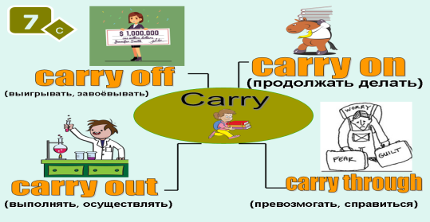 | Students' attention is drawn to the lesson.  Determines the topic and purpose of the lesson  Learners talk about favourite dayprevious lesson vocabulary  Students say different words from the picture and count one to hundred | At the organization moment T tries to award active Ss.  “Good job!  Well done!” | Pictures  PPT
Middle of the lesson  Presentation part.  35 min | Ex:5 P:81  Read out the box and explain the task.  Give Ss time to complete the task.  Check Ss' answers.  Ex:6 P:81  Explain the task and ask Ss to read the statements 1-5.  Play the recording, then Ss listen and mark the statements according to what they hear.  Check Ss' answers.  Differentiation:  «Verbal support» method is used to help Students ue new words in the  Ex: 7 P:81  Ask Ss to work in groups of three and give them time to prepare interview questions and answers referring back to the text.  Then ask various groups to act out their interviews in front of the class. | Students choose the correct particle. Make sentences using the other options.  ANSWERS:  1 on  2 out  3 off  Students listen to a conversation between two friends talking about music and mark the statements.  ANSWERS:  1 F  2 T  3 T  4 F  5 F  Students you are a TV presenter interviewing Gani and Rashida about Dalatunes. Take roles. Use the information in the text.  ANSWERS:  A: What made you set up Dalatunes?  B: We were worried people would forget about Kazakh music if they had access to all sorts of other music through the internet.  A: When did you set it up?  C: In 2014.  A: What sort of music can you find on Dalatunes?  B: Anything from the 7th century to the present day as well as videos, lyrics and chords and much more.  A: Is the site popular?  C: Yes, it is. We now have our own offices in Almaty, we have a radio station, too.  A: What languages is the site available in?  B: Russian and English so it's accessible to more people.  A: Well, thanks for talking to me today.  B/C: You're welcome | Descriptor:  - choose the correct particle  - make sentences  Total: 2 point  Descriptor:  - listen to a conversation  - mark the statements  Total: 2 point  Descriptor:  - work in groups  - Use the information in the text  Total: 1 point  -Make CCQ questions  Yes / No | Cards  Student’s book  Worksheets  Student’s book
End of the lesson  5 mi | Giving the hometask.  Ex: 3 P:23 wb  Self-reflectio | Ss evaluate each other and encourage classmate with phrases like:  Well done! Brilliant! Good job! I like it! |  | Poster Success

Short term plan Term 3

Unit 7 Music and films. |  | Lesson 75

Teacher name:

Date:
Grade: 9 |  | Number present: | absent:
Lesson title | Everyday English: Inviting, Accepting, Refusing
Learning objectives | 9.2.4.1 understand most of the implied meaning in unsupported extended talk on a wide range of general and curricular topics;  9.3.7.1 use appropriate subject-specific vocabulary and syntax to talk about an increased range of general and curricular topics
Lesson objectives | Learners will be able to:  - present situational language and understand its function  - predict the content of a dialogue and listen and read for gist
Value links | "Independence and patriotism",  To the past, present and future of the people understand the relevance
Plan

Stages / Time | Teachers’ actions | Students’ actions | Assessment criteria | Resources
Beginning of the lesson  5 min | 1.Greeting.  Ask about the weather.  Warming-up  The teacher sets the lesson objectives, letting students know what to anticipate from the lesson.  Lead – In  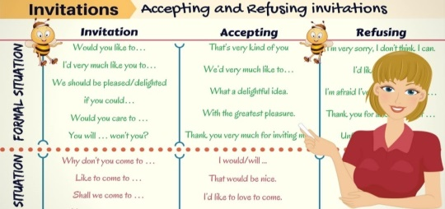 | Students' attention is drawn to the lesson.  Determines the topic and purpose of the lesson  Learners talk about favourite dayprevious lesson vocabulary  Students say different words from the picture and count one to hundred | At the organization moment T tries to award active Ss.  “Good job!  Well done!” | Pictures  PPT
Middle of the lesson  Presentation part.  35 min | Ex:1 P:82  Play the recording. Ss listen and repeat chorally or individually. Pay attention to Ss' pronunciation and intonation.  Explain what the words invite, accept and refuse mean, read out the sentences and elicit the function of each one.  Ex:2 P:82  Direct Ss' attention to the posters and elicit what each one is about (A - a film festival, B - a concert).  Play the recording. Ss listen and follow the dialogue in their books and find out which event the dialogue is about.  Differentiation:  «Verbal support» method is used to help Students ue new words in the  Ex: 3 P:82  Explain the situation. Direct Ss to the useful language box and tell them they can use these phrases in their dialogue.  Ss work in pairs and take turns inviting and accepting/refusing.  Monitor the activity around the class and then ask various pairs to act out their dialogues in front of the class. To help Ss draw the following diagram on the board and elicit appropriate phrases Ss should use. Write them on the board, Ss can refer to the diagram while doing the task  Ex: 4a P:82  Play the recording with pauses for Ss to repeat chorally and/or individually.  Pay attention to Ss' intonation and pronunciation. Emphasise the strong forms  Ex: 4b P:82  Read out the theory box and play the recording. Ss listen and point out the weak and strong forms. | Students listen and say. Answer the question  ANSWERS:  invite: Do you fancy going to ...?  accept: Sounds good!, No problem!, Alright then!, Count me in! refuse: Sorry, I can't make it.  Students read the dialogue between two friends. Listen, read and say.  ANSWERS:  It is about the film festival in poster A.  Students use phrases from the dialogue to act out a similar dialogue for the other poster.  ANSWERS:  A: What are you doing on Friday night, Bill?  B: I'm not sure. I haven't planned anything yet.  A: How about going to a live concert?  B: A live concert! Why not? I haven't been to one in ages. What kind of a concert is it?  A: It's the Profilers. I'm sure you'll like them.  B: Sounds good! When is it exactly?  A: It's at 9:30 at the Music Mania Club.  B: OK! Count me in.  A: Alright then! See you on Friday  Students listen and repeat  ANSWERS:  Students own answer  Students listen and identify the weak.  ANSWERS:  1 Have (w) have (3)  2 Does (w) does(s) | Descriptor:  - listen and say  - answer the question  Total: 2 point  Descriptor:  - read the dialogue  - read and say.  Total: 2 point  Descriptor:  - use phrases from the dialogue  - act out a similar dialogue  Total: 1 point  Descriptor:  - listen and repeat  Total: 1 point  -Make CCQ questions  Yes / No | Cards  Student’s book  Worksheets  Student’s book
End of the lesson  5 min | Giving the hometask.  Ex: 3 P:23 wb  Self-reflectio | Ss evaluate each other and encourage classmate with phrases like:  Well done! Brilliant! Good job! I like it! |  | Poster Success

Short term plan Term 3

Unit 7 Music and films. |  | Lesson 76

Teacher name:

Date:
Grade: 9 |  | Number present: | absent:
Lesson title | Across cultures: Dancing around the world  Summative assessment for the unit 7
Learning objectives | 9.2.1.1 understand the main points in unsupported extended talk on a wide range of general and curricular topics, including talk on a limited range of unfamiliar topics  9.4.5.1 deduce meaning from context in extended texts on a wide range of familiar general and curricular topics, and some unfamiliar topics  9.5.3.1 write with moderate grammatical accuracy on a wide range of familiar general and curricular topics;
Lesson objectives | Learners will be able to:  - introduce the topic and describe pictures  -read for specific information  - identify adjectives and compound adjectives
Value links | "Independence and patriotism"  Respect the state symbols of Kazakhstan, understand the meaning of public holidays
Plan

Stages / Time | Teachers’ actions | Students’ actions | Assessment criteria | Resources
Beginning of the lesson  5 min | 1.Greeting.  Ask about the weather.  Warming-up  The teacher sets the lesson objectives, letting students know what to anticipate from the lesson.  Lead – In   | Students' attention is drawn to the lesson.  Determines the topic and purpose of the lesson  Learners talk about favourite dayprevious lesson vocabulary  Students say different words from the picture and count one to hundred | At the organization moment T tries to award active Ss.  “Good job!  Well done!” | Pictures  PPT
Middle of the lesson  Presentation part.  35 min | Ex:1 P:83  Direct Ss' attention to the pictures and go through the list of phrases.  Explain/Elicit the meanings of any unknown words and then ask various Ss to describe the pictures to the rest of the class.  Ex:2 P:83  Play the recording. Ss listen and follow the text in their books and say which dance welcomes spring.  Ex: 3 P:83  Ask Ss to read the questions 1-4, then give Ss time to read the text again and answer the questions.  Check Ss' answers.  Ex: 4 P:83  Give Ss time to look through the texts again and complete the task.  Check Ss' answers.  Summative assessment for the unit 7 | Students look at the picture. Use these phrases to describe them.  ANSWERS:  Picture A shows men dressed in white trousers and white shirts and they are wearing hats. They are playing drums, accordions and pipes. They also have knee bells on their legs.  Picture B shows a woman in a brightly-coloured dress and a man in a traditional suit. They are dancing. They are both wearing hats  Students listen and read to find out. Answer the questions  ANSWERS:  Morris dancing.  Students read again and answer the question  ANSWERS:  1 Morris dancers use drums, accordions and pipes.  2 You can see Morris dancing in the spring.  3 It is usually performed by a couple or a group of couples who hop and sway back and forth making movements with their shoulders and their arms.  4 It imitates horse riding.  Students find all the adjectives and compound adjectives in the text.  ANSWERS:  Students own answer  traditional, various, lively, energetic, different, best known, black, white, colourful, spring, popular, female, brightly-coloured, large, upbeat, national | Descriptor:  - look at the picture.  - these phrases to describe  Total: 2 point  Descriptor:  - listen and read to find out  - answer the questions  Total: 2 point  Descriptor:  - read again  - read again  Total: 1 point  Descriptor:  - find all the adjectives  - complete the task  Total: 1 point  -Make CCQ questions  Yes / No | Cards  Student’s book  Worksheets  Student’s book
End of the lesson  5 min | Giving the hometask.  Ex: 3 P:23 wb  Self-reflectio | Ss evaluate each other and encourage classmate with phrases like:  Well done! Brilliant! Good job! I like it! |  | Poster Success

Short term plan Term 3

Unit 7 Music and films. |  | Lesson 77

Teacher name:

Date:
Grade: 9 |  | Number present: | absent:
Lesson title | Across the curriculum: the four elements of music
Learning objectives | 9.3.5.1 keep interaction going in basic exchanges on a growing range of general and curricular topics  9.4.7.1 recognize typical features at word, sentence and text level in a wide range of written genres, including some which focus on unfamiliar topics
Lesson objectives | Learners will be able to:  - present new vocabulary for musical instruments  -identify rhythm and tempo  - read for cohesion and coherence
Value links | "Independence and patriotism"  Respect the state symbols of Kazakhstan, understand the meaning of public holidays
Plan

Stages / Time | Teachers’ actions | Students’ actions | Assessment criteria | Resources
Beginning of the lesson  5 min | 1.Greeting.  Ask about the weather.\  Warming-up  The teacher sets the lesson objectives, letting students know what to anticipate from the lesson.  Lead – In  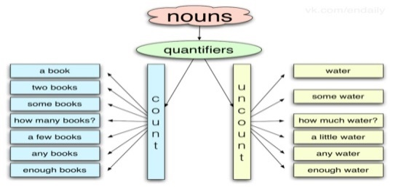 | Students' attention is drawn to the lesson.  Determines the topic and purpose of the lesson  Learners talk about favourite dayprevious lesson vocabulary  Students say different words from the picture and count one to hundred | At the organization moment T tries to award active Ss.  “Good job!  Well done!” | Pictures  PPT
Middle of the lesson  Presentation part.  35 min | Ex:1 P:8 4  Elicit the musical instruments by asking for descriptions or asking Ss to draw pictures on the board or by using flashcards.  Tell Ss they are going to hear different pieces of music played by these instruments.  Play the recording twice if necessary. Ss listen and number the musical instruments in the order they hear them.  Ex:2 P:84  Explain the task.  Play the recording and then elicit the answers to the questions.  Ex: 3a P:84  Give Ss time to read the text and then elicit what it is about.  Ex: 3b P:84  Give Ss time to read the text again and fill the gaps with the appropriate quantifiers from the list.  Play the recording for Ss to listen and check their answers. | Students listen and number the musical instruments in the order.  ANSWERS:  1 trumpet  2 guitar  3 banjo  4 flute  5 piano  6 harp  7 saxophone  8 drums  Students listen to some piano extracts. Answer the question.  ANSWERS:  1 loud and fast  2 quiet and slow  Students look at the text. Listen and check  ANSWERS:  The text is about the four elements of music: melody, harmony, rhythm and dynamics.  Students fill in the correct quantifiers.  ANSWERS:  1 many  2 lot  3 much  4 few  5 Some  6 any | Descriptor:  - listen and number listen and number  Total: 2 point  Descriptor:  - listen to some piano extracts.  - answer the questions  Total: 2 point  Descriptor:  - look at the text  - read again  Total: 1 point  Descriptor:  - fill in the correct quantifiers  - complete the task  Total: 1 point  -Make CCQ questions  Yes / No | Student’s book
End of the lesson  5 min | Giving the hometask.  Ex: 3 P:23 wb  Self-reflectio | Ss evaluate each other and encourage classmate with phrases like:  Well done! Brilliant! Good job! I like it! |  | Poster Success

Short term plan: term 3

Unit 7 Music and films. |  | Lesson 78

Teacher name:

Date:
Grade: 9 |  | Number present: | absent:
Lesson title | Summative Assessment for term 3
Learning objectives | 9.2.5.1 recognize the attitude or opinion of the speaker(s) in unsupported extended talk on a wide range of general and curricular topics, including talk on a limited range of unfamiliar topics  9.3.7.1 use appropriate subject-specific vocabulary and syntax to talk about an increased range of general and curricular topics  9.4.3.1 understand the detail of an argument- both explicitly stated and implied - in extended texts on a wide range of familiar general and curricular topics, and some unfamiliar topics  9.5.6.1 write coherently at text level using a variety of connectors on a growing range of familiar general and curricular topic
Lesson objectives | Learners will be able to:
Plan

Stages / Time | Teachers’ actions | Students’ actions | Assessment criteria | Resources
Beginning of the lesson  5 min | Organization moment  1.Greeting.  Ask about the weather.  The teacher sets the lesson objectives, letting students know what to anticipate from the lesson.  Warm-up  • With books closed, ask students to recall the previous lesson (Speaking, page 86) and elicit what they remember about the scenario.  • Ask: Where was the woman? (In a shop.) What was she doing? (Returning a record.) What did she want? (To change it.) Did she get what she wanted?  LISTENING  Task. Listen to five people talking about different celebrations. Match the halves of the sentences (1-4) with the opinions (A-F) to make true sentences. ONE argument is extra. CD3 Tapescript3 | Students' attention is drawn to the lesson.  Students discuss the pictures in pairs.  Determines the topic and aim of the lesson  Students say different words from the picture  Students Listen to five people talking about different celebrations then match  Descriptor:  - listen and match | Formative Assessment  Good job!  -can match the halves of the sentences  Total: 6 point
Middle of the lesson  Presentation part.  35 min | Task. Choose and circle the correct answer A, B or C  READING  Task. Paraphrase the given sentences so it has similar meaning. Use the given beginnings of sentences. Example, No kitchen was needed to prepare popcorn. Preparation _________________________. Answer, Preparation of popcorn did not need any kitchen  Task. Answer the questions.  5. Why have cinemas sold popcorn since the 19th century?  6. Why cannot popcorn be dissapperead from cinemas?  WRITING  Choose ONE of the topics and write.  Topic 1. You are a blogger who shares with own experience. Write a story about a concert you have been to. Include the following information in your review:.  • The concert; when? / where?  • The band: people in the band/ kind of music/ songs played  • The audience: how many people / their reaction  • Problems: the music/ the sound quality/ the time  • Suggestions: different place / different time / different kind of music  SPEAKING  Task. You are given questions to speak about for 2-3 minutes. Before you speak you have one minute to think about what you are going to say. | Students  Descriptor:  - Paraphrase the given sentences so it has similar meaning  Students choose ONE of the topics and write.  Descriptor:  - Write a story about a concert  Students answer the question  Descriptor: | -can paraphrase the given sentences  Total: 6 point  -can write a story about a concert  Total: 6 point  -can answer the question  Total: 6 point
End of the lesson  5 min | FEEDBACK  Learners provide feedback on what they have learned at the lesson. | Students evaluate each other and encourage classmate with phrases like:  Well done! Brilliant! Good job! I like it! . |  | Poster

Short term plan Term 3

Unit 7 Music and films. |  | Lesson 79

Teacher name:

Date:
Grade: 9 |  | Number present: | absent:
Lesson title | Writing: you can’t save the world alone
Learning objectives | 9.4.5.1 deduce meaning from context in extended texts on a range of familiar general and curricular topics  9.5.2.1 write independently about factual and imaginary past events, activities and experiences on a range of familiar general and curricular topics  9.6.7.1 use a variety of simple perfect forms including some passive forms including time adverbials on a range of familiar general and curricular topics
Lesson objectives | Learners will be able to:  - analyse a model review  -identify and classify adjectives
Value links | "Independence and patriotism"  Respect the state symbols of Kazakhstan, understand the meaning of public holidays
Plan

Stages / Time | Teachers’ actions | Students’ actions | Assessment criteria | Resources
Beginning of the lesson  5 min | 1.Greeting.  Ask about the weather.  Warming-up  The teacher sets the lesson objectives, letting students know what to anticipate from the lesson.  Lead – In  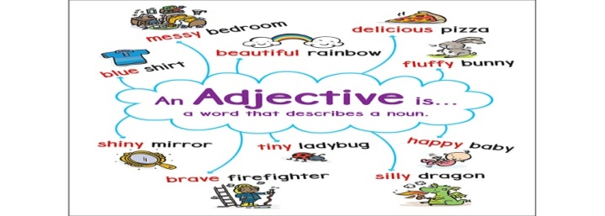 | Students' attention is drawn to the lesson.  Determines the topic and purpose of the lesson  Learners talk about favourite dayprevious lesson vocabulary  Students say different words from the picture and count one to hundred | At the organization moment T tries to award active Ss.  “Good job!  Well done!” | Pictures  PPT
Middle of the lesson  Presentation part.  35 min | Ex:1 P:8 5  Give Ss time to read the email and match the paragraphs to the headings.  Check Ss' answers.  Ex:2 P:85  Read out the list of adjectives. Explain/Elicit the meanings of any unknown ones and the write the headings on the board.  Elicit which adjectives go under which heading and write them on the board. Ask Ss to copy the completed table into their notebooks.  Ask Ss to look back through the review and find the nouns that the adjectives describe.  Ex: 3 P:84  Read the sentences aloud and elicit which express positive and which express negative opinions. | Students read the email and match the paragraph to the headings.  ANSWERS:  1 B  2 D  3 A  4 C  5 E  Students look at the adjectives. Identify the adjectives.  ANSWERS:  negative: evil, weak  neutral: big-budget, action  positive: good, powerful, fast-paced, excellent, impressive, amazing, funny  good films, big-budget action film, powerful evil villain, fast-paced film (Justice League), excellent acting, impressive special effects, amazing stunts, funny script, weak plot  Students read the sentences. Identify the express opinions  ANSWERS:  1 positive  2 positive  3 positive  4 negative | Descriptor:  - read the email  - match the paragraph  Total: 2 point  Descriptor:  - look at the adjectives  - find the nouns that the adjectives describe  Total: 2 point  Descriptor:  - read the sentences  - Identify the express opinions  Total: 1 point  -Make CCQ questions  Yes / No | Student’s book
End of the lesson  5 min | Giving the hometask.  Ex: 3 P:23 wb  Self-reflectio | Ss evaluate each other and encourage classmate with phrases like:  Well done! Brilliant! Good job! I like it! |  | Poster Success

Short term plan Term 3

Unit 7 Music and films. |  | Lesson 80

Teacher name:

Date:
Grade: 9 |  | Number present: | absent:
Lesson title | Edutainment
Learning objectives | 9.4.4.1 read a wide range of extended fiction and non-fiction texts on familiar and unfamiliar general and curricular topics  9.3.2.1 ask complex questions to get information about a wide range of general and curricular topics  9.2.5.1 recognize the attitude or opinion of the speaker(s) in unsupported extended talk on a wide range of general and curricular topics, including talk on a limited range of unfamiliar topics
Lesson objectives | Learners will be able to:  - match sentences to meanings and introduce the value of inspiration  -test knowledge learnt in this module/ to do a quiz  -consolidate vocabulary learnt in the module/to write a quiz
Value links | "Independence and patriotism",  To the past, present and future of the people understand the relevance
Plan

Stages / Time | Teachers’ actions | Students’ actions | Assessment criteria | Resources
Beginning of the lesson  5 min | 1.Greeting.  Ask about the weather.  Warming-up  The teacher sets the lesson objectives, letting students know what to anticipate from the lesson. | Students' attention is drawn to the lesson.  Determines the topic and purpose of the lesson  Learners talk about favourite dayprevious lesson vocabulary  Students say different words from the picture and count one to hundred | At the organization moment T tries to award active Ss.  “Good job!  Well done!” | Pictures  PPT
Middle of the lesson  Presentation part.  35 min | Ex:1 P:8 6  •Ask Ss to read the sentences 1-6 and the meanings A-F and give them time to match them.  Explain/Elicit the meanings of any unknown words.  Elicit answers from Ss around the class.  Ex:2 P:86  Ask Ss to discuss the question in pairs and talk about how music can inspire us.  Monitor the activity around the class and then ask various Ss to tell the class.  Ex: 3 P:86  Explain the task. Allow Ss some time to read the statements and mark them as true or false.  Tell Ss they can review the module and find the relevant information to help them if necessary.  Check Ss' answers.  Ex:4 P:86  Explain the task and give Ss time to work in pairs and look through the module and think of quiz questions.  Tell Ss they can use the quiz in the previous task as a model.  Ss can swap their quiz with another pair and do it and then report back to the class.  Ex:5 P:86  Read the rubric and the title aloud.  Elicit from Ss how the title might be related to the phrases.  Play the recording. Ss listen and follow the song in their books to find out. | Students match the sentences to their meanings.  ANSWERS:  1 D  2 F  3 B  4 A  5 E  6 C  Students answer the question. Discuss in pairs.  ANSWERS:  A: I think music inspires us because it takes us away from everyday life and it helps us to think more deeply about things. For example, we use it when we exercise to focus and we use it when we study to help us concentrate.  B: Yes. I think you're right about that. I also think that music can inspire us to do better and try harder and live better lives. When we listen to a song with a good tune and a strong message it has an impact on us  Students do the quiz. Mark the sentences. Correct the false statements.  ANSWERS:  1 T 2T  3 F (Melody is the tone or pitch.)  4 T  5 F (the UK)  6 F (England)  7 T  8 T  Students go through Module 7 and write a quiz of your own.  ANSWERS:  1 Aisholpan Nurgaiv is a girl. (T)  2 Otto Bell is an eagle hunter. (F-Film director)  3 The theme of The Eagle Huntress is sung by Sia. (1)  4 Kassa is a rock band. (T)  5 KeshYOU plays pop music.(T)  6 Morris dancers wear bells on their hats. (F-flowers)  7 Male dancers in the Kara Zhorga wear hats with a feather. (F-female dancers)  8 The dynamics of a piece of music relates to the speed of it. (F-how to play it  Students look at the title of the song. Answer the question.  ANSWERS:  I think the title of the song refers to stardom and fame. To be a star, you need to 'get the breaks', 'have what it takes, and so on | Descriptor:  - match the sentences  - complete the task  Total: 2 point  Descriptor:  - answer the question.  - discuss in pairs  Total: 2 point  Descriptor:  - do the quiz  - mark the sentences  Total: 1 point  Descriptor:  - write a quiz of your own.  - complete the task  Total: 1 point  Descriptor:  - look at the title  - answer the question.  Total: 1 point  -Make CCQ questions  Yes / No | Student’s book
End of the lesson  5 min | Giving the hometask.  Ex: 3 P:23 wb  Self-reflectio | Ss evaluate each other and encourage classmate with phrases like:  Well done! Brilliant! Good job! I like it! |  | Poster Success

